


SOUTHWEST UNIVERSITY OF SCIENCE AND TECHNOLOGY
PROJECT TITLE
CloudPOS – Role-Based Point of Sale System
TEAM MEMBERS:
FRIMPONG MAAME ACHIAA (4420230903)
TRUONG QUANG NGHIA (4420230904)
KARIM OUSSAMA (4420230906)

DEGREE: BACHELOR OF ENGINEERING
COURSE INSTRUCTOR: Dr LORD BLESS

Table of Contents
Chapter one 7
1. Introduction 7
1.1. Background 7
1.2. Problem Statement 7
1.3. Objectives 8
1.4. Scope 8
Chapter two 10
2.System Analysis and Requirements 10
2.1. System Overview 10
2.2. Functional Requirements 10
2.3. Non-Functional Requirements 11
2.4. Use Case Diagram 12
Figure 1: Use case diagram 12
2.4.1 Explanation 12
Chapter Three 14
3. System And Software Design 14
3.1. POS System – CloudPOS - System Architecture & Design Patterns 14
3.1.1. High-Level System Architecture 14
Figure 2: High-Level System Architecture Diagram 14
3.1.2. Design Patterns Used 15
Figure 3: Design Patterns Diagram 15
3.2. Object-Oriented Class Diagram 16
3.2.1. Complete UML Class Diagram 16
Figure 4: UML Class Diagram 16
3.2.2. Online Architecture 17
Figure 5: Online Architecture Diagram 17
3.2.3. Explanation 17
3.3. Sequence Diagram 18
Figure 6: Sequence Diagram 18
Figure 7 19
Figure 8 19
3.3.1. Key Relationships Summary 20
3.4. Activity Diagram 20
Figure 9: Activity Diagram 20
Figure 10 21
3.5. Work Breakdown Structure (WBS) 22
Figure 11: Work Breakdown Structure Diagram 22
3.6. Gantt Chart 23
Figure 12: Gantt Chart Diagram 23
3.7. Activity Network Diagram 23
Figure 13: Activity Network Diagram 24
3.7.1. Critical Path Analysis (PERT/CPM) 24
Figure 14: Critical Path Analysis 24
Chapter Four 25
4. Implementation 25
4.1. Tools and Technologies 25
4.1.1. Programming Language 25
4.1.2. Graphical User Interface (GUI) Framework 25
4.1.3. Database Technologies 26
4.1.4. Cloud & Synchronization 26
4.1.5. PDF Generation (Receipts) 26
4.1.6. Development Tools 27
4.1.7. Hardware Requirements (Deployment) 27
4.2. Technology Stack Summary Diagram 28
Figure 15: Technology Stack Summary Diagram 28
4.3. System Architecture 29
4.3.1. High-Level Architecture Overview 29
4.3.2. Architecture Diagram 30
Figure 16: Architecture Diagram 30
4.4. System Modules 31
Figure 17: System Modules Diagram 31
4.5. Key Features 32
4.5.1. Feature Summary Table 32
Figure 18: Feature Summary Table 32
4.6. Screenshots 32
Figure 19: SignUp Page 33
Figure 20: Login Page 33
Figure 21: Admin’s Dashboard 33
Figure 23: Cashier’s Dashboard 34
Figure 24: Manager’s Dashboard 35
Figure 26: Settings 36
Figure 27: Reports 36
Figure 28: Audit Logs 37
Chapter Five 38
Testing and Evaluation 38
5.1 Introduction 38
5.2 Overview of Testing 38
5.3 Testing Concepts 39
5.4 Test Cases 40
Table 5.4.1 Login Authentication 40
Table 5.4.2 Product Management 41
Table 5.4.3 Sales Processing 41
Table 5.4.4 Payment Processing 41
5.5 Testing Activities 42
5.6 Unit Testing 43
Figure 29 44
Figure 30 45
Figure 31 45
Figure 32 46
5.7 Integration Testing 46
Figure 33 47
Figure 5.7: Integration Testing 48
5.8 System Testing 48
Figure 34 49
Figure 35 50
Figure 36 52
Figure 37 53
Figure 38 53
Figure 39 55
Figure 40 55
Figure 41 56
Figure 42 58
Figure 43 58
Figure 44 59
Figure 45 60
Figure 46 61
Figure 47 61
Figure 48 62
Figure 49 63
Figure 50 63
Figure 51 65
Figure 52 66
Figure 53 66
Figure 54: System Testing 67
5.9 User Acceptance Testing 68
5.10 The POS Testing Pyramid: 69
Figure 55: POS Testing Pyramid 69
5.11 Regression Testing 69
5.12 Test Incident Reporting: 70
5.13 Additional Test Cases 71
5.14 System Performance 73
5.15 Challenges 73
5.16 Conclusion 74
5.17 Future Work 75
Chapter Six 76
5. Individual Contribution and Self-Assessment 76
6.1. Student Name 76
6.1.1. Role 76
6.1.2. Task Completed 76
6.1.3. Contribution Percentage 78
6.1.4. Challenges 78
6.1.5. Skills Gained 79
6.1.6. Reflection 80
6.1.7. Contribution Evidence 85
Figure 56 85
Figure 57 86
Figure 58 86
6.2. Peer Assesment 87
Chapter Seven 89
7. System Deployment 89
7.2. Deployment Strategy Overview 89
7.3. Tools and Technologies Used 89
7.4. Detailed Deployment Workflow 90
Step 1: Initialize and Configure Cloud Backend (Supabase) 90
Step 2: Link Source Code and Deploy Database Schema 90
Step 3: Deploy Edge Functions (Server-side Logic) 90
Step 4: Set Up Desktop Client Environment 90
Step 5: Application Packaging 91
Step 6: Launch and Operate the System 91
7.5. Post-Deployment Verification 91
7.6. Operations and Security Standards (Best Practices) 91

\

Chapter one

1. Introduction

1.1. Background
Retail businesses, especially small to medium-sized enterprises (SMEs), face significant operational challenges in managing over-the-counter sales, tracking staff actions, preventing revenue loss, and maintaining inventory accuracy. Traditional POS systems often lack structured shift management, granular access control, and reliable data synchronization when internet connectivity is intermittent.
The goal is to build a desktop-based POS system using Python, integrated with a cloud database, that enforces strict role-based access control (RBAC), supports shift-level accountability, and enables offline operation with cloud synchronization.
Key Technical Drivers
- Cloud-First but Offline-Capable: Centralized data management with local resilience.
- Role-Based Access Control (Admin, Manager, Cashier): Prevents unauthorized actions and reduces internal fraud.
- Shift-Level Reconciliation: Ens every cashier’s session is tracked from opening to closing balance.

1.2. Problem Statement
Many retail POS systems in use today suffer from the following critical issues:
- Weak Access Control – Cashiers and managers often share login credentials, leading to audit trails that cannot identify individual responsibility.
- No Formal Shift Management – There is no systematic way to track opening cash balances, sales during a shift, and closing counts, making cash theft or errors hard to detect.
- Revenue Leakage – Without split payment tracking, receipt generation, and approval workflows, revenue can be lost through unrecorded transactions or unauthorized discounts.
- Poor Offline Handling – When internet fails, many systems stop working entirely, causing business disruption.
- Inflexible User Account Creation – Public registration or insecure account creation allows unauthorized system access.
Therefore, there is a clear need for a secure, modular, offline-first POS system that enforces role hierarchy, shift accountability, and reliable transaction logging.

1.3. Objectives
1. Implement a secure authentication module using cloud authentication with hashed passwords and Row Level Security (RLS).

2. Enforce a 3-tier role hierarchy (Admin, Manager, Cashier) where only Admins can create new staff accounts.

3. Build a POS terminal with fast product search (by barcode or name), cart management, and split payment (cash + bank transfer).

4. Automatically generate PDF receipts for every completed sale (simulating thermal printer output).

5. Support offline operation – continue sales when internet is lost, then sync to cloud when reconnected.

1.4. Scope
In Scope (What the Project Will Deliver)
- Fully functional desktop POS application (Windows/Linux compatible) written in Python.

- Cloud database integration with:
  - Product table (barcode, name, price, attributes, image URL)
  - Users table (hashed password, role, name, shift history)
  - Sales transaction table (items, total, split payment details, shift ID, timestamp)
  - Shift table (cashier ID, open time, close time, opening balance, closing balance, discrepancy)
- Authentication & role-based UI – Different dashboards for Admin, Manager, Cashier.
- Sales terminal – Cart, payment, change calculation, split payment, PDF receipt.
- Product management (CRUD) – Only for Admin and Manager, with validation.
- Offline-first sync mechanism – Local queue + cloud upload on reconnects.
- Basic reporting – Shift summary, sales by date.

Chapter two

2.System Analysis and Requirements

2.1. System Overview
The Point of Sale (POS) System is designed to manage retail sales operations efficiently, securely, and reliably. It allows cashiers to process customer purchases, accept payments, generate receipts, and manage daily register activities.
The system supports different user roles such as Admin, Manager, and Cashier, where each role has specific permissions based on responsibility. Cashiers handle daily transactions, managers supervise sales and cash activities, and admins manage users, roles, and system settings.
A key part of the system is its offline-first capability. Sales can continue even when there is no internet connection by storing data locally in SQLite. Once the connection is restored, the system synchronizes the local data with the central PostgreSQL database.

2.2. Functional Requirements
The system consists of the following core modules:
1. Module Authentication & Role Management
- Centralized Login: Uses Cloud Auth for user authentication.
- 3-Tier Role Hierarchy:
Admin: Full authority to manage staff accounts and access all system functions.
Manager: Manages products, approves sensitive tasks, and handles shift reconciliation.
Cashier: Limited to opening/closing shifts and performing sales transactions.
- Restriction on Public Registration: Only Admins have the authority to create new staff accounts.

2. Module POS Terminal (Sales & Payment)
- High-Speed Operations: Fast product searching via text box (supports barcode or product name).
- Cart Management: Add, edit quantities, and remove items from the cart.
- Flexible Payment: Processes payments and automatically calculates change. Supports Split Payment (e.g., partial cash and partial bank transfer).
- Receipt Generation: Exports transaction invoices as PDF files (simulating thermal printing) for storage and verification.

3. Module Inventory & Product Management
- Product Lifecycle Management (CRUD): Add, View, Update, and Delete product information (Barcode, Name, Price, Attributes).
- Image Management: Store and retrieve product images via Cloud Storage or local offline storage.

2.3. Non-Functional Requirements
1. Performance: Database optimized with SQL Indexes to ensure fast product querying and invoice generation.

2. Security: Passwords are hashed one-way by Cloud Auth. Implements Row Level Security (RLS) to secure the database.

3. Usability: Interface uses standard technical English with a minimalist design, focusing on Data Grids instead of large graphical buttons.

4. Maintainability: Source code architecture is clearly separated into modules: UI Logic, Database Access, and Business Logic.

2.4. Use Case Diagram
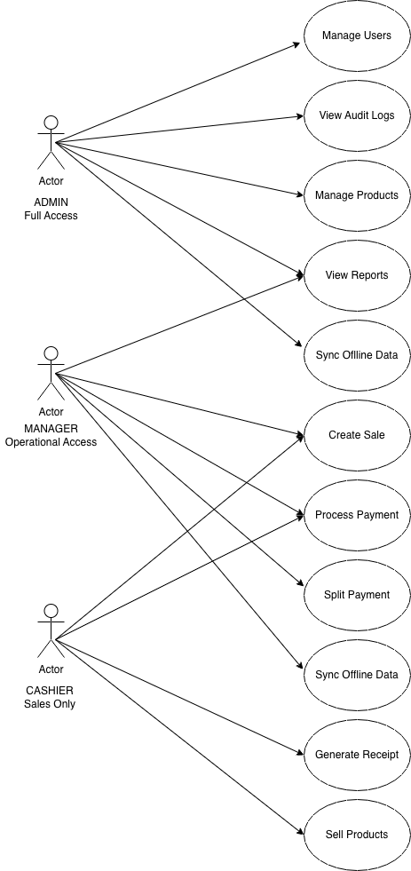

Figure 1: Use case diagram

2.4.1 Explanation
The diagram represents a Point of Sale (POS) system where three main actors Cashier, Manager, and Admin interact with the system based on their responsibilities.
- The Cashier handles day-to-day operations like creating sales, processing payments, selling products and generating receipts.
- The Manager oversees operations, monitors performance, and reviews reports and cash activities.
- The admin controls the system at a higher level, including managing users, permissions, and overall system configuration.
All interactions happen inside the POS system boundary, which groups core business processes such as sales handling, cash/register control, reporting, user management, hardware usage, offline operation, and security.
The diagram shows how:
- Complex actions (like completing a sale or generating reports) are made up of smaller required steps (<<include>> relationships).
- The system supports real-world retail workflows, including handling cash, tracking user actions, and integrating with hardware.
- It is designed to be offline-first, meaning operations continue locally and sync later with a central system.
- Security and audit mechanisms ensure traceability and controlled access.

Chapter Three

3. System And Software Design

3.1. POS System – CloudPOS - System Architecture & Design Patterns

3.1.1. High-Level System Architecture
The system follows a Layered (N-Tier) Architecture combined with an Offline-First Cloud Sync Pattern. This ensures separation of concerns, maintainability, and resilience to network failures.
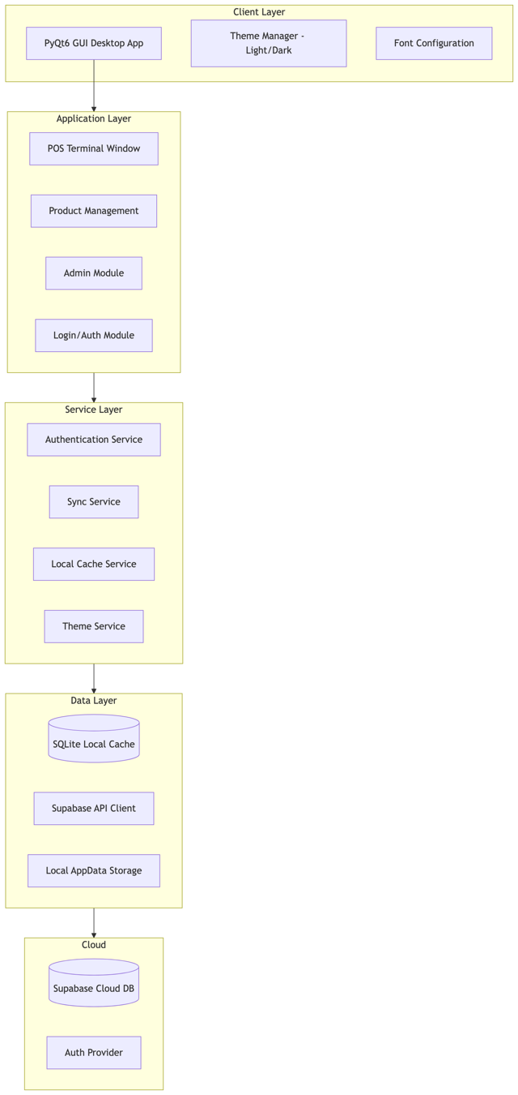

Figure 2: High-Level System Architecture Diagram

3.1.2. Design Patterns Used

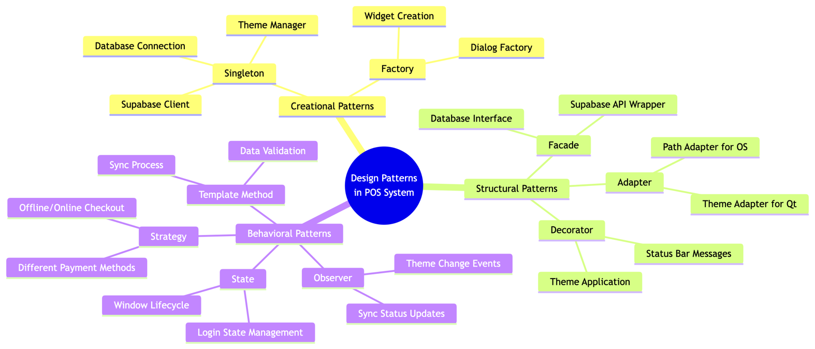

Figure 3: Design Patterns Diagram

3.2. Object-Oriented Class Diagram

3.2.1. Complete UML Class Diagram
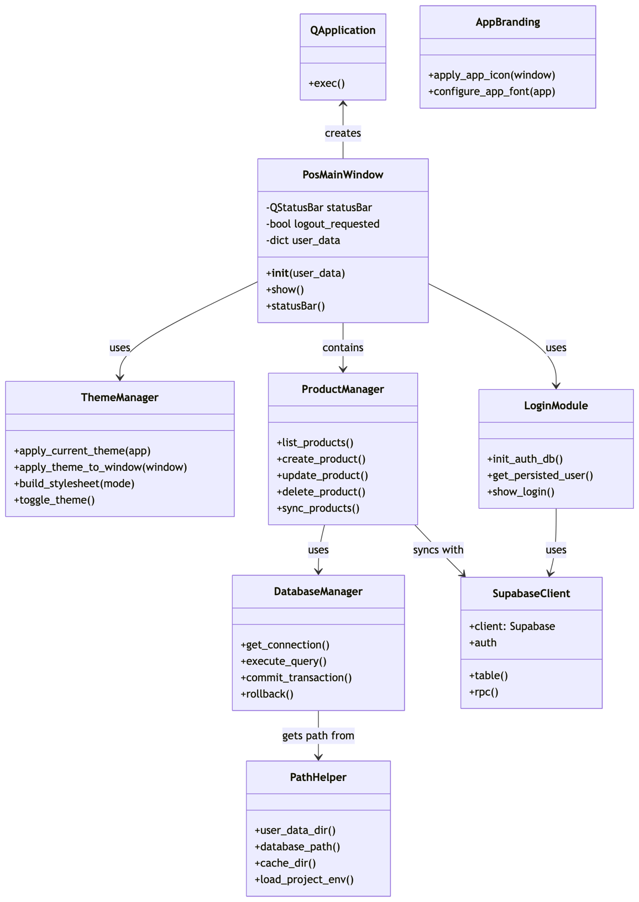

Figure 4: UML Class Diagram

3.2.2. Online Architecture

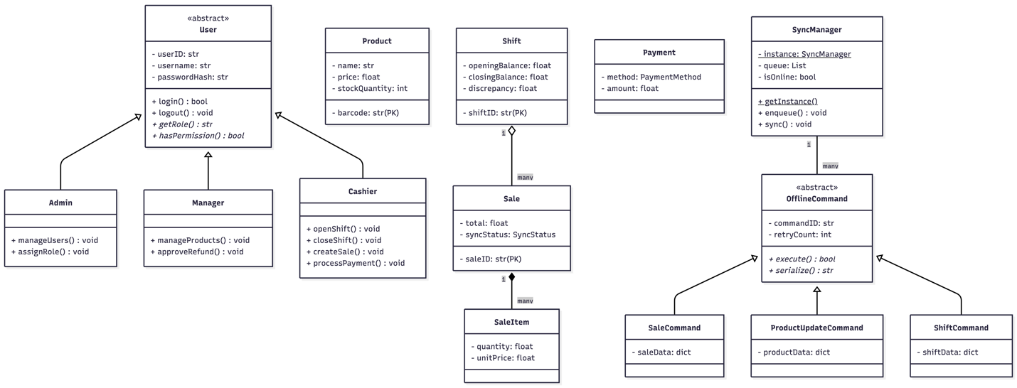

Figure 5: Online Architecture Diagram

3.2.3. Explanation
Abstract Class Diagram
The Abstract Class Diagram illustrates the core object-oriented structure of the CloudPOS system. At the center is the abstract User class, which cannot be instantiated directly but serves as a blueprint for three specific user roles: Admin, Manager, and Cashier. The abstract class contains common attributes such as userID, username, passwordHash, and email, along with concrete methods like login() and logout() that work identically for all users. Two abstract methods, getRole() and hasPermission(), force each subclass to define its own role name and permission boundaries.
The Admin has full system access with methods to manage users and assign roles. The Manager has limited access focused on product management and shift reconciliation. The Cashier has minimal access restricted to opening shifts, creating sales, and processing payments. This three-tier hierarchy enforces strict role-based access control.
The diagram also shows four core business entities. Product stores item details including barcode, name, price, and stock quantity. Shift tracks each cashier's work session with opening balance, closing balance, expected balance, and discrepancy calculation—critical for preventing revenue leakage. Sale represents a customer transaction linked to a specific shift and cashier. SaleItem records individual line items within a sale, storing denormalized product names to preserve historical accuracy even if product information changes later.

Offline Command Diagram
The Offline Command Diagram shows how the system maintains functionality during network outages. At the top is the abstract OfflineCommand class, which defines attributes like commandID, type, createdAt, and retryCount, along with abstract methods execute() and serialize(). Three concrete command classes inherit from it: SaleCommand, ProductUpdateCommand, and ShiftCommand. Each stores the relevant data as a dictionary and implements the execute method to upload to the cloud when online.
The SyncManager uses the Singleton pattern, ensuring only one instance exists. It maintains a queue of pending commands, monitors network connectivity through the isOnline flag, and provides methods to enqueue commands and trigger synchronization. When the system is online, commands execute immediately on the cloud database. When offline, commands are serialized to JSON and stored in a local SQLite queue. Upon reconnection, the SyncManager flushes the queue in FIFO order, with failed commands retrying up to three times. This architecture ensures business continuity during internet outages while maintaining data integrity.

3.3. Sequence Diagram
Login and Authentication Sequence
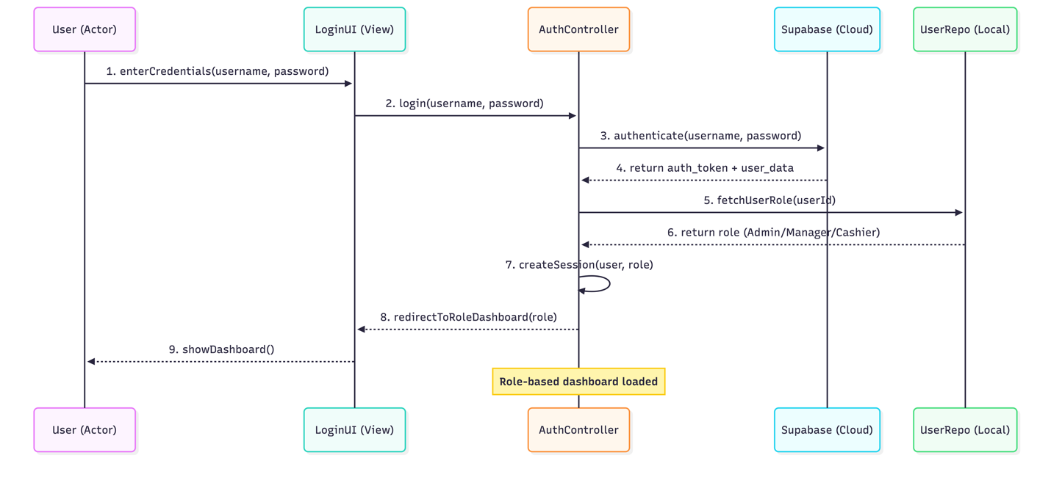

Figure 6: Sequence Diagram

Open Shift Sequence
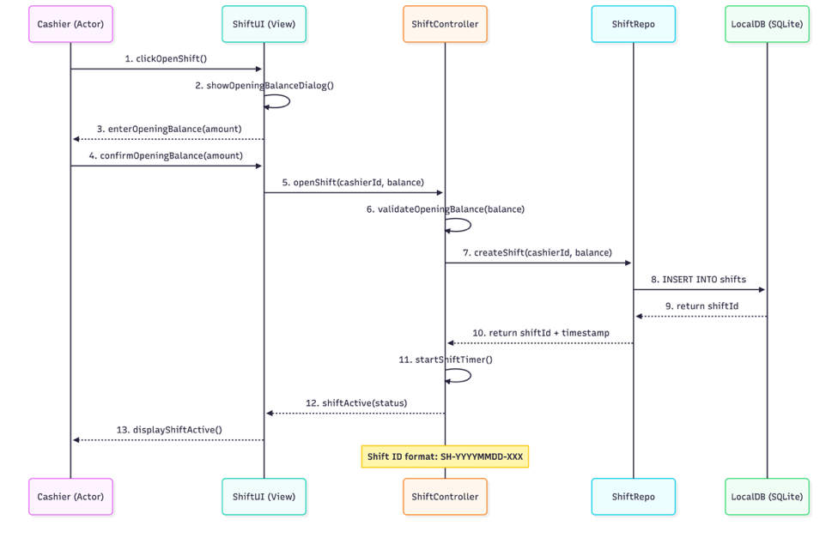

Figure 7

Create Sale and Process Payment Sequence
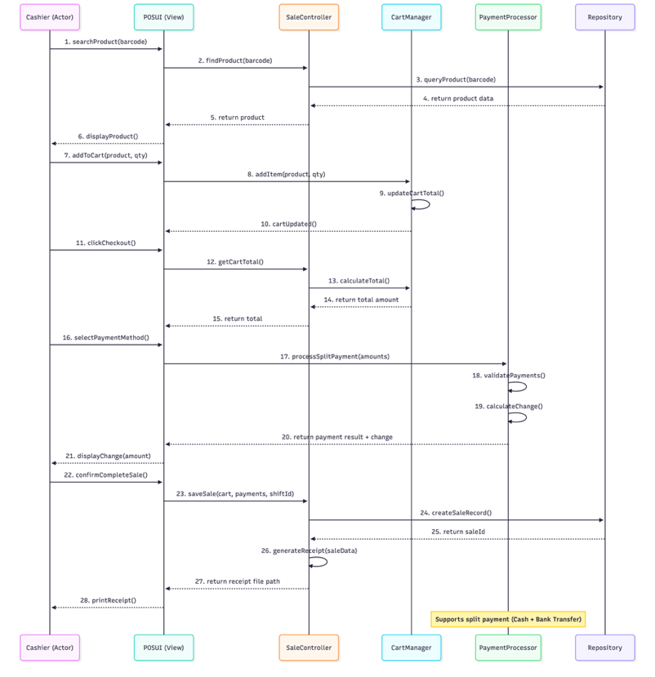

Figure 8

3.3.1. Key Relationships Summary
Relationship | From | To | Cardinality
Inheritance | Admin, Manager, Cashier | User | -
Composition | Sale | SaleItem | 1 : *
Aggregation | Shift | Sale | 1 : *
Association | Sale | Payment | 1 : *
Realization | SaleCommand | OfflineCommand | -

3.4. Activity Diagram
Login and Authentication Activity Diagram

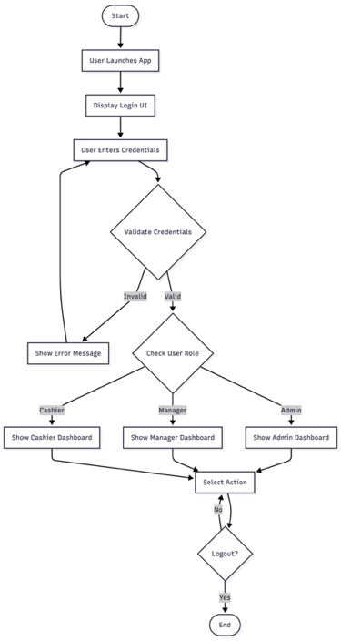

Figure 9: Activity Diagram

Open Shift Activity Diagram
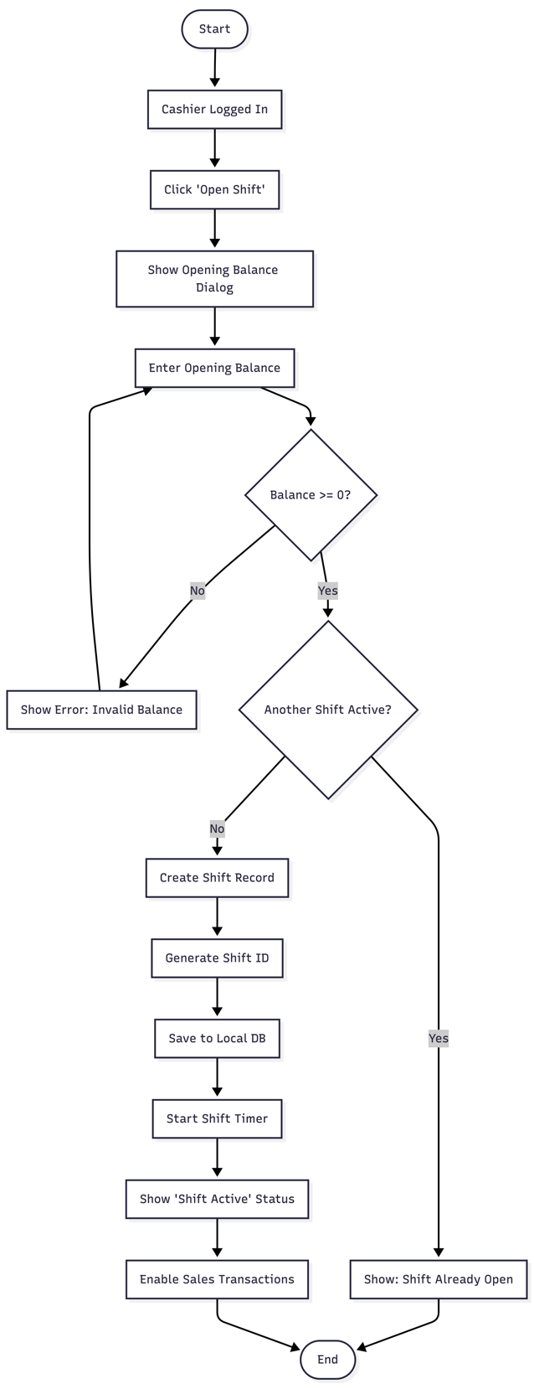

Figure 10

3.5. Work Breakdown Structure (WBS)
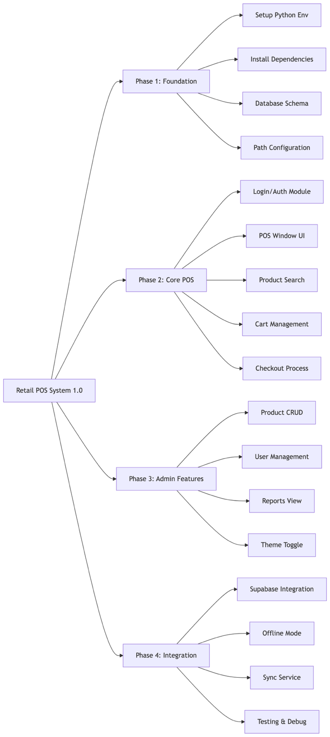

Figure 11: Work Breakdown Structure Diagram

3.6. Gantt Chart

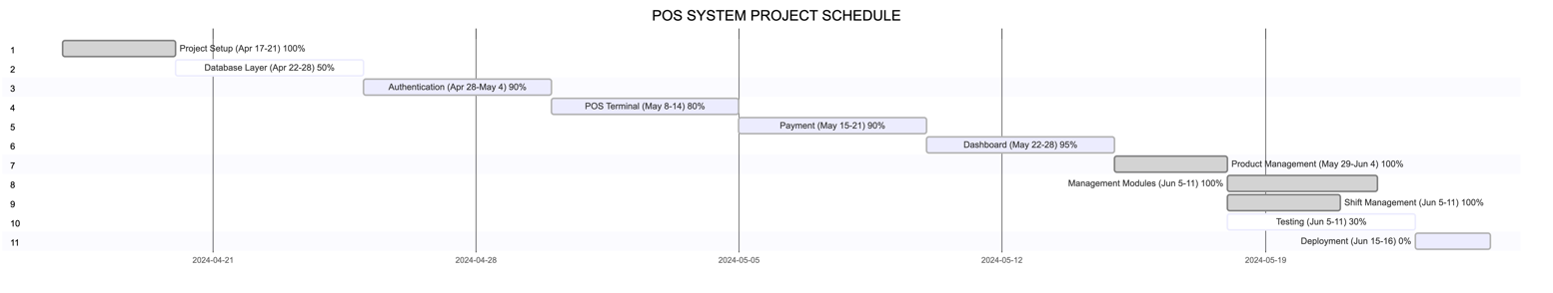

Figure 12: Gantt Chart Diagram

3.7. Activity Network Diagram

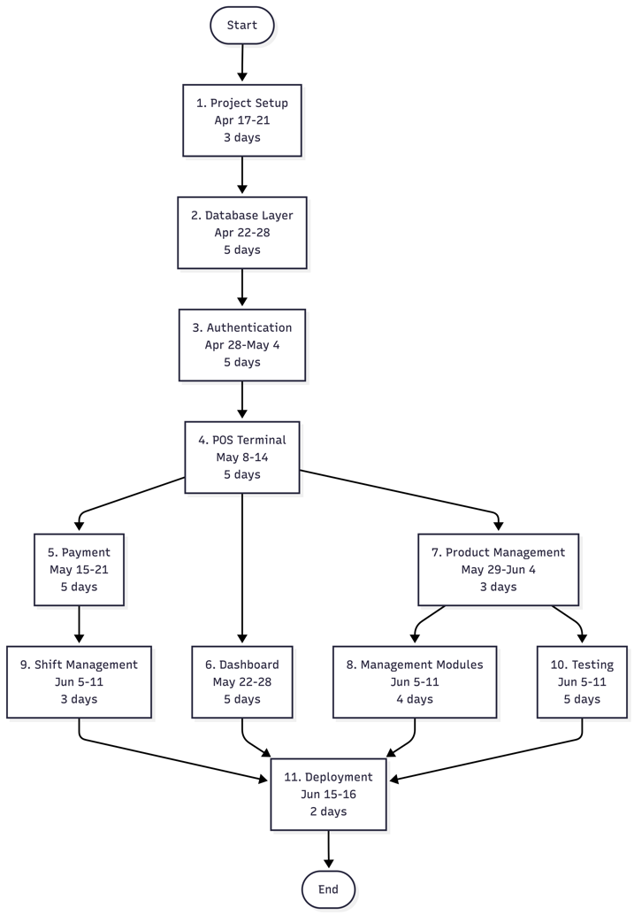

Figure 13: Activity Network Diagram

3.7.1. Critical Path Analysis (PERT/CPM)
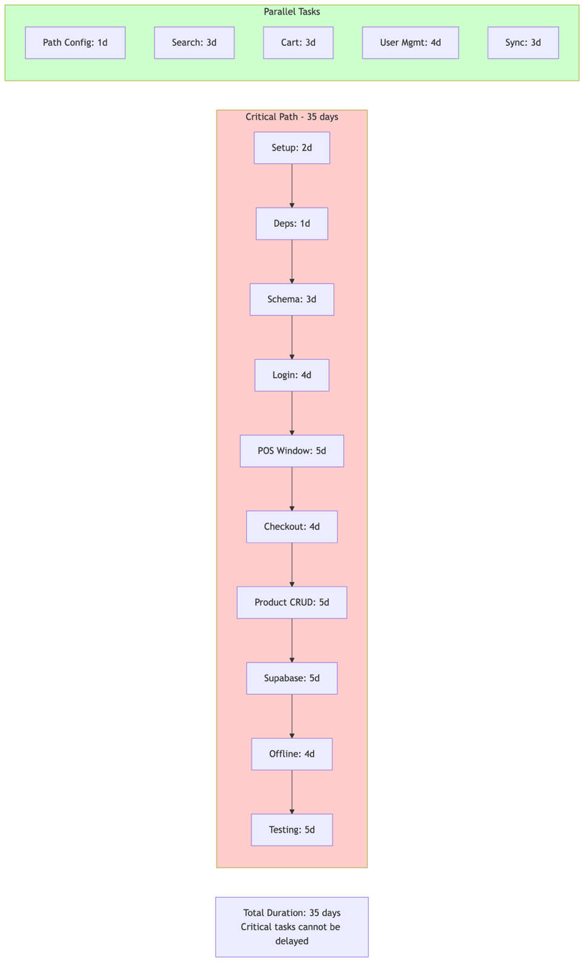

Figure 14: Critical Path Analysis

Chapter Four

4. Implementation

4.1. Tools and Technologies

4.1.1. Programming Language
Technology | Version | Purpose
Python | 3.12 | Core programming language for desktop application development
Why Python?
- Rapid development and prototyping capabilities
- Extensive library support for GUI, database, PDF generation, and cloud integration
- Cross-platform compatibility (Windows, macOS)
- Strong community support for POS system development

4.1.2. Graphical User Interface (GUI) Framework
Technology | Version | Purpose
Tkinter | Built-in Python 3 | Primary UI framework for desktop application
ttk | Built-in | Themed widgets for modern appearance
Alternative Considered: PyQt6 (more advanced but heavier)
Selected: Tkinter – Lightweight, no additional dependencies, sufficient for minimalist data-grid design.

4.1.3. Database Technologies
Technology | Version | Purpose
Supabase | Latest | Cloud database with built-in authentication and Row Level Security (RLS)
PostgreSQL | 14+ | Underlying cloud database (provided by Supabase)
Why Supabase?
- Built-in authentication with password hashing
- Row Level Security (RLS) for role-based data access
- Real-time capabilities for sync status
- PostgreSQL compatibility (indexes, complex queries)

4.1.4. Cloud & Synchronization
Technology | Version | Purpose
Supabase Client | 2.0+ | Python client for cloud database operations
Python-dotenv | 1.0+ | Environment variable management for credentials

4.1.5. PDF Generation (Receipts)
Technology | Version | Purpose
PyQt6 | 6.7.1 | To generate and display receipts within the POS terminal window (likely as a QTextEdit or QDialog showing formatted text/HTML), not as physical printed  paper.

4.1.6. Development Tools
Tool | Version | Purpose
VS Code | Latest | Integrated development environment
Git | 2.40+ | Version control
GitHub | - | Remote repository and collaboration
Postman | Latest | API testing for cloud endpoints
Draw.io | - | Diagram creation (architecture, class diagram)
PyInstaller | 5.0+ | Executable build for distribution
Mermaid Live Editor - Diagram creation (class diagram, Gantt chart, activity diagram)

4.1.7. Hardware Requirements (Deployment)
Component | Minimum Specification
Processor | Intel Core i3 or equivalent
RAM | 4 GB
Storage | 500 MB free space
Display | 1366×768 resolution
Network | Wi-Fi/Ethernet (intermittent connectivity acceptable)
OS | Windows 10/11

4.2. Technology Stack Summary Diagram

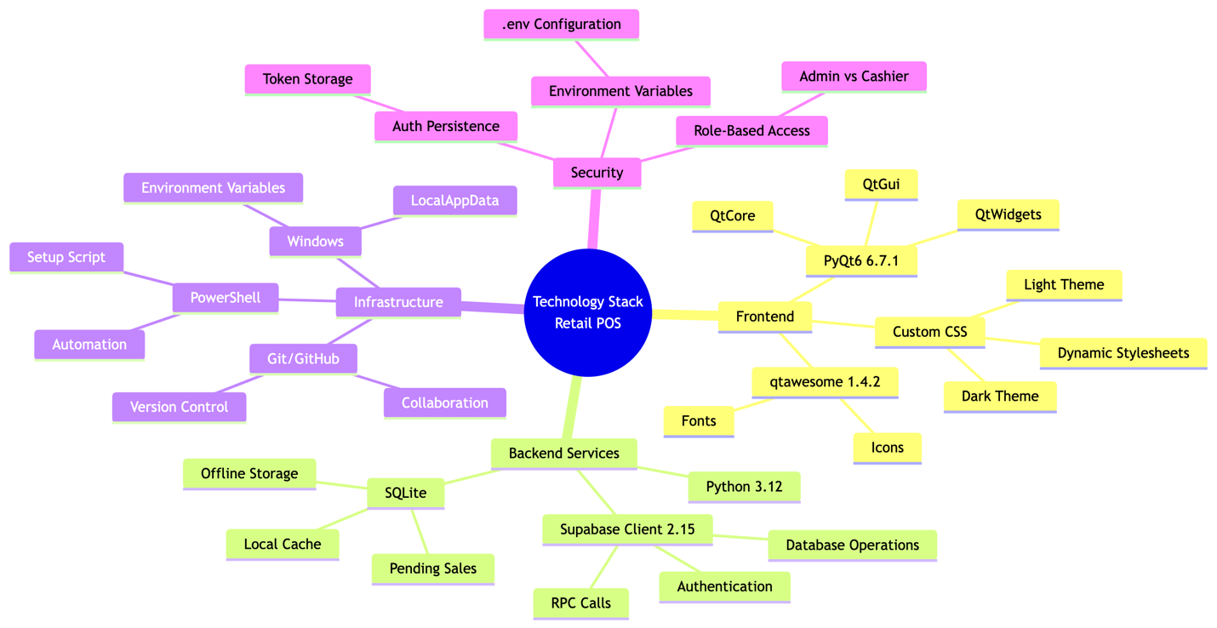

Figure 15: Technology Stack Summary Diagram

4.3. System Architecture

4.3.1. High-Level Architecture Overview

The CloudPOS system follows a Layered (N-Tier) Architecture with Offline-First capabilities. The architecture is divided into four distinct layers:
Layer | Responsibility | Components
Presentation Layer | User interface and user interaction | Tkinter windows, dialogs, data grids
Business Logic Layer | Core application logic and rules | Controllers, validators, calculators
Data Access Layer | Database abstraction and synchronization | Repositories, SyncManager, Cloud/Local adapters
Data Layer | Persistent storage | Supabase Cloud,

4.3.2. Architecture Diagram
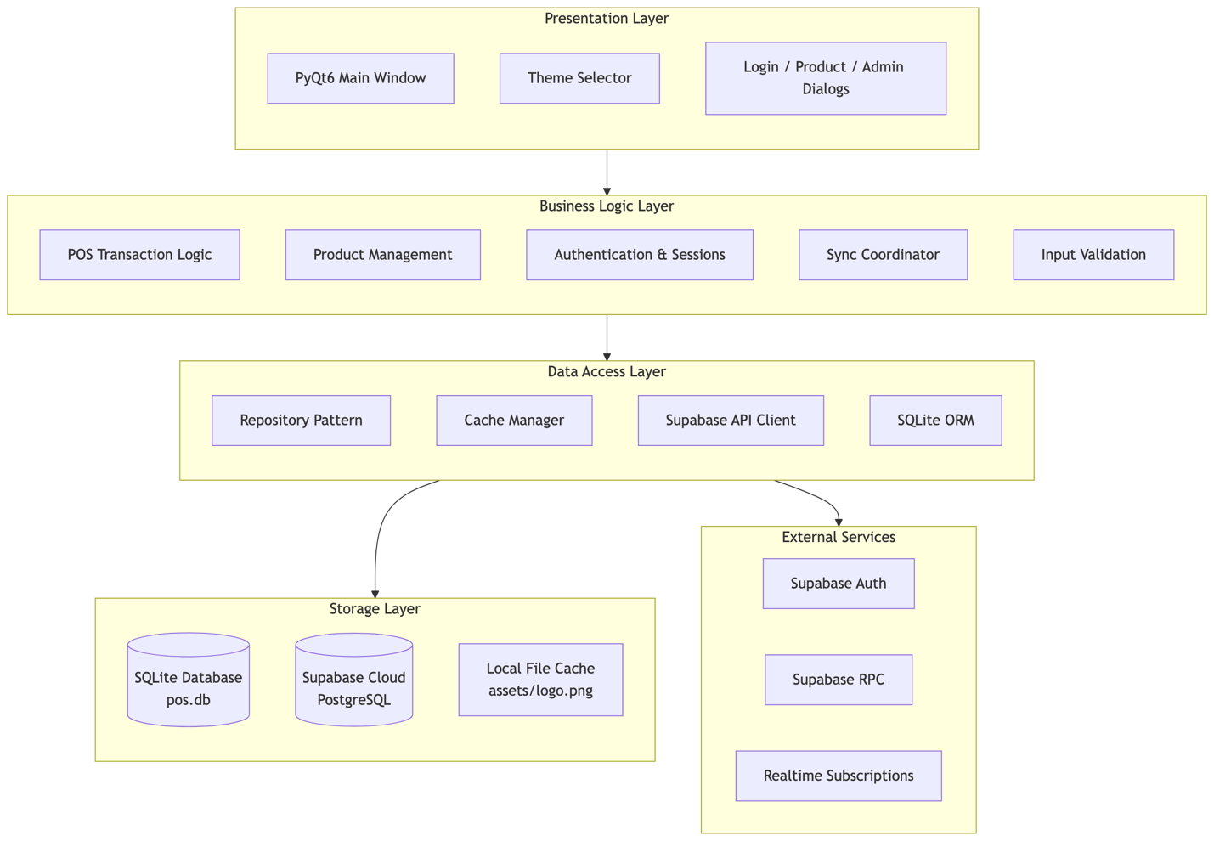

Figure 16: Architecture Diagram

4.4. System Modules
The system is divided into seven core modules, each responsible for a specific functional area.
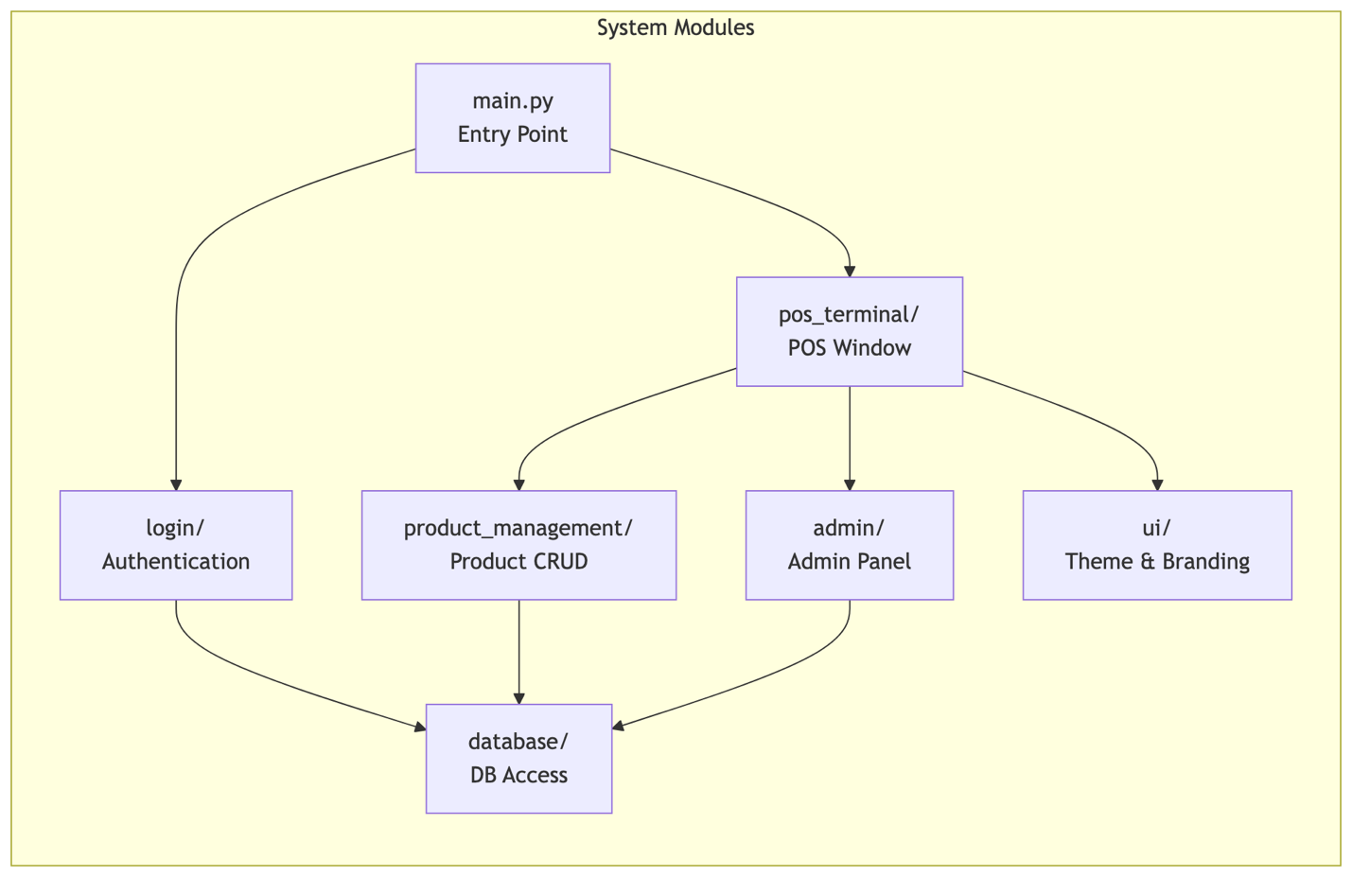

Figure 17: System Modules Diagram

Module | Responsibility
main.py | Application entry point, orchestrates login loop, creates main window
pos_terminal/ | POS checkout interface, cart management, sale processing
login/ | User authentication, session persistence, role validation
product_management/ | Product CRUD operations, inventory management
admin/ | User management, system configuration, reports
database/ | SQLite local cache, Supabase sync, data persistence
ui/ | Theme management (light/dark), app branding, fonts, icons

4.5. Key Features

4.5.1. Feature Summary Table

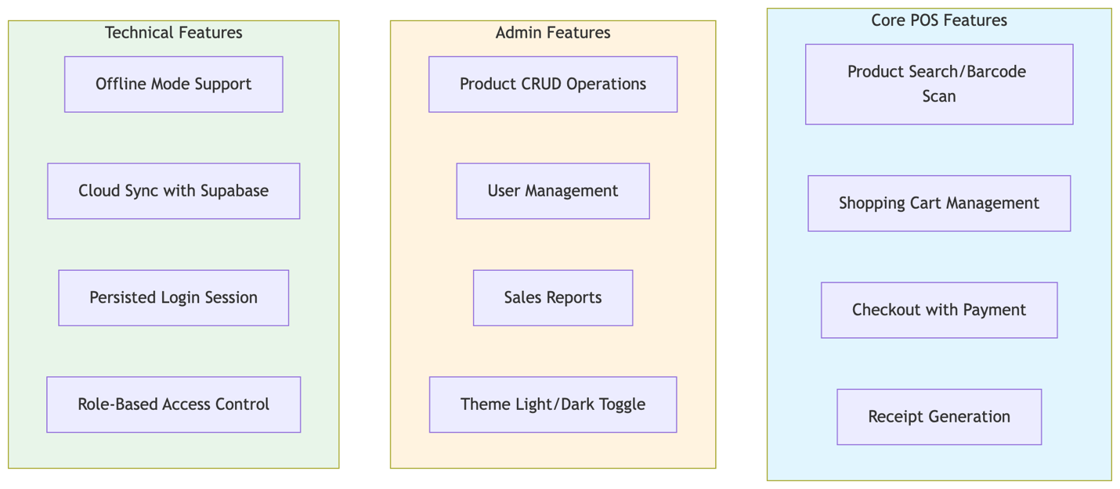

Figure 18: Feature Summary Table

4.6. Screenshots
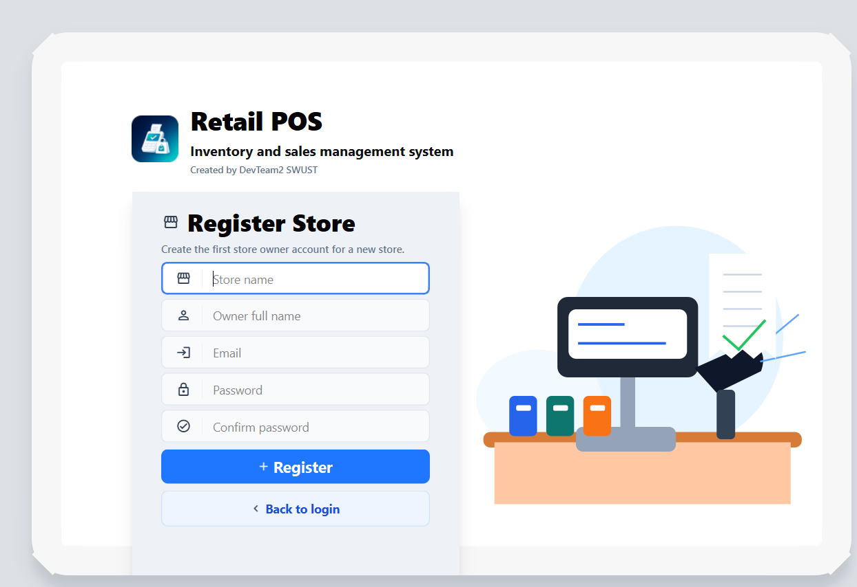

Figure 19: SignUp Page
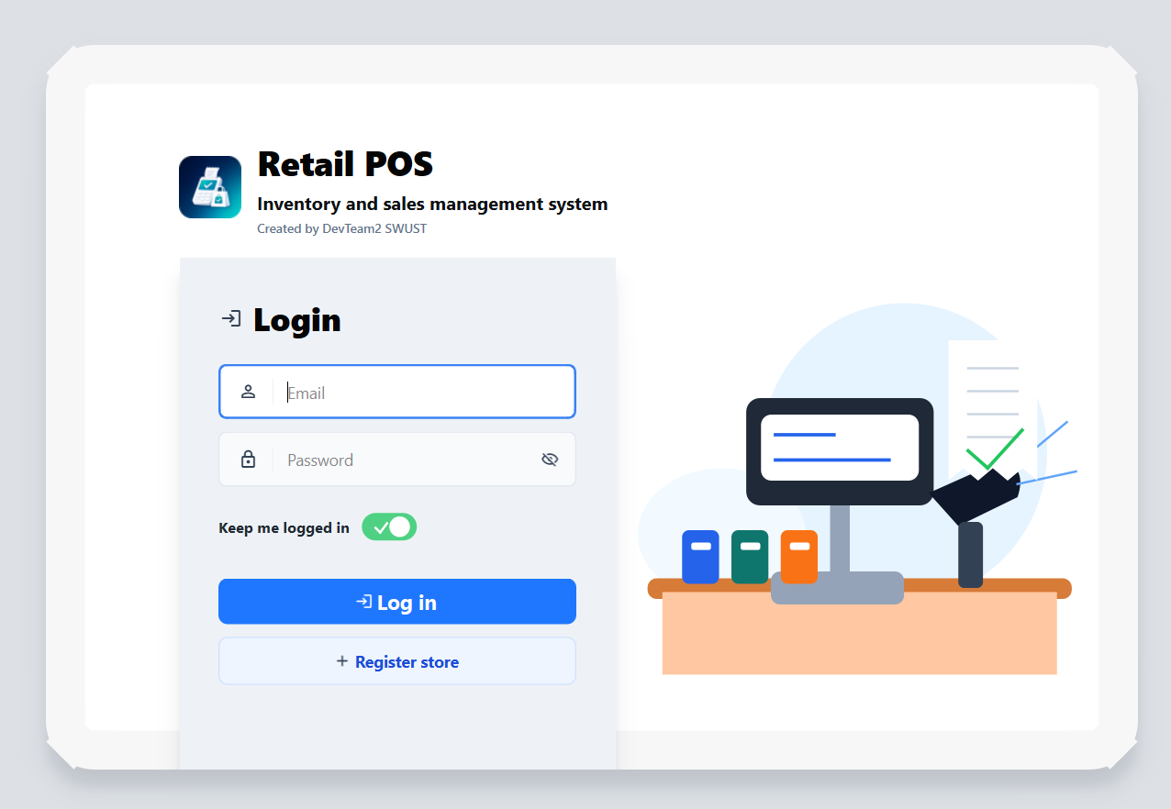

Figure 20: Login Page

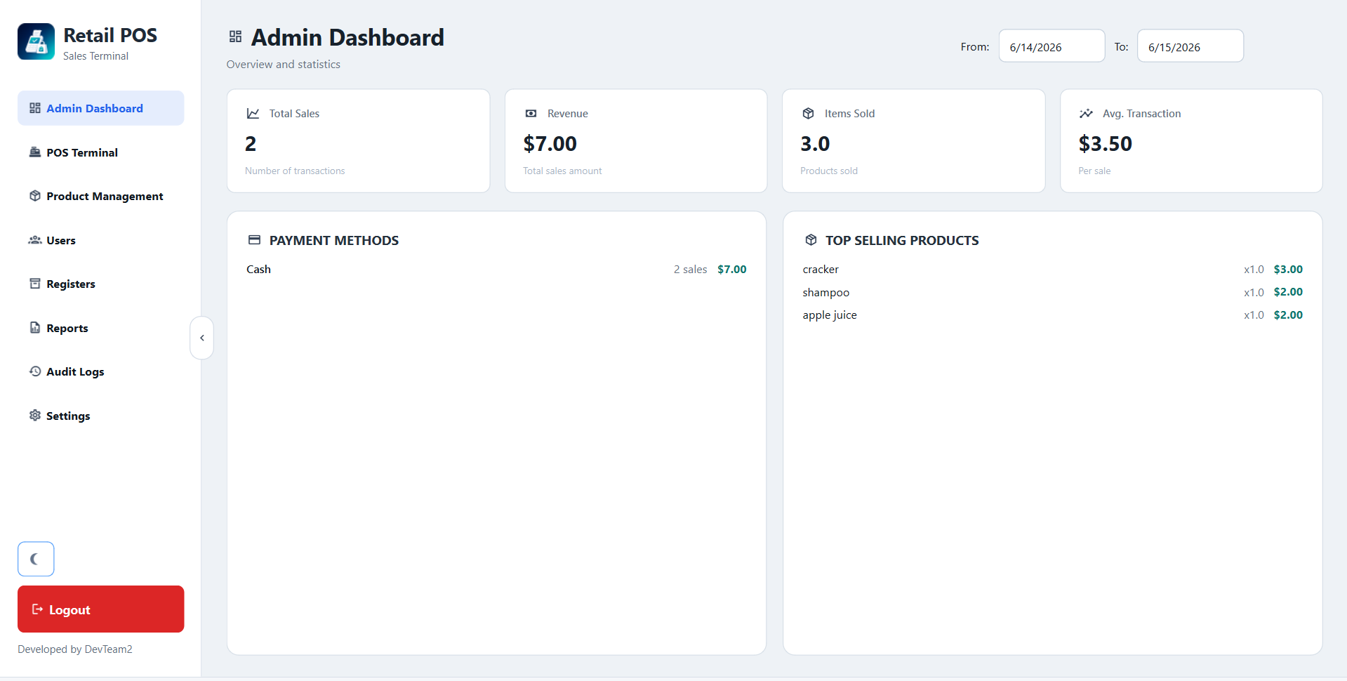

Figure 21: Admin’s Dashboard

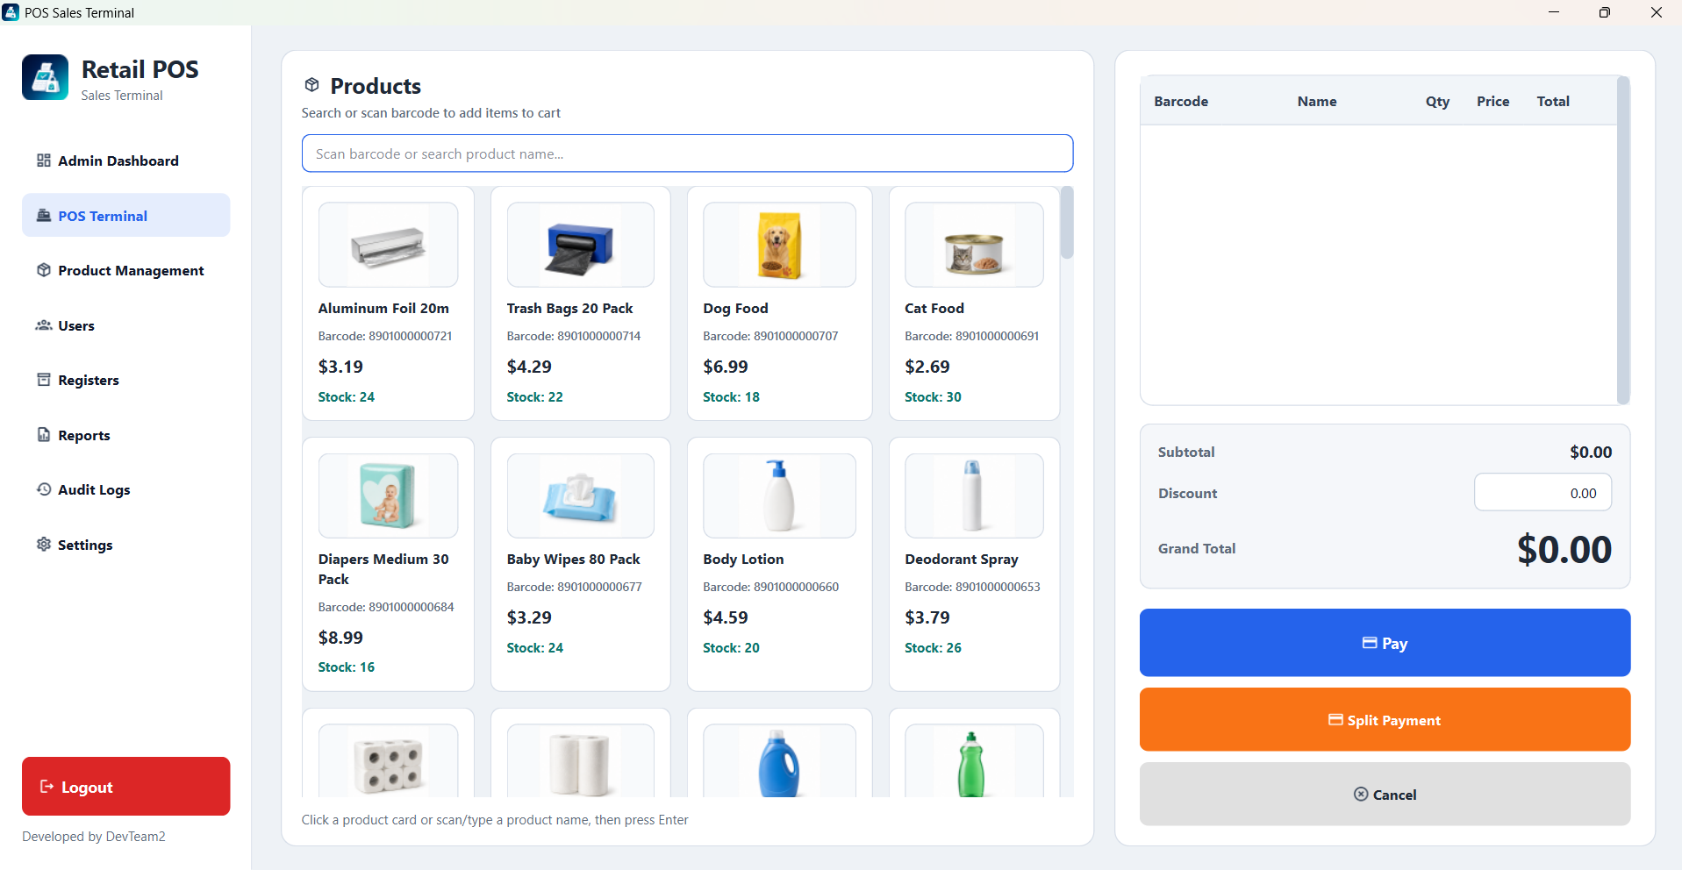Figure 22: POS Terminal

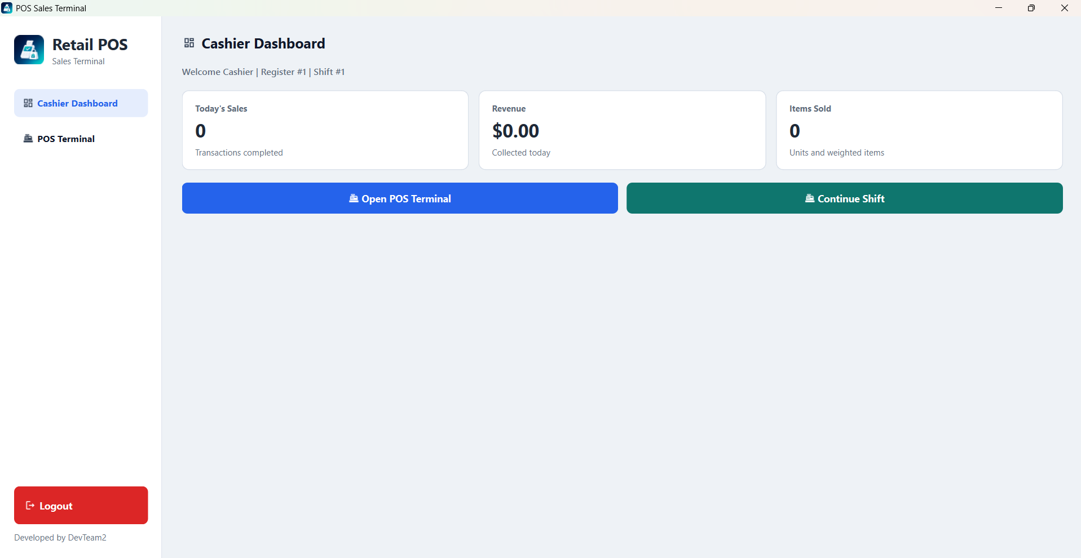

Figure 23: Cashier’s Dashboard

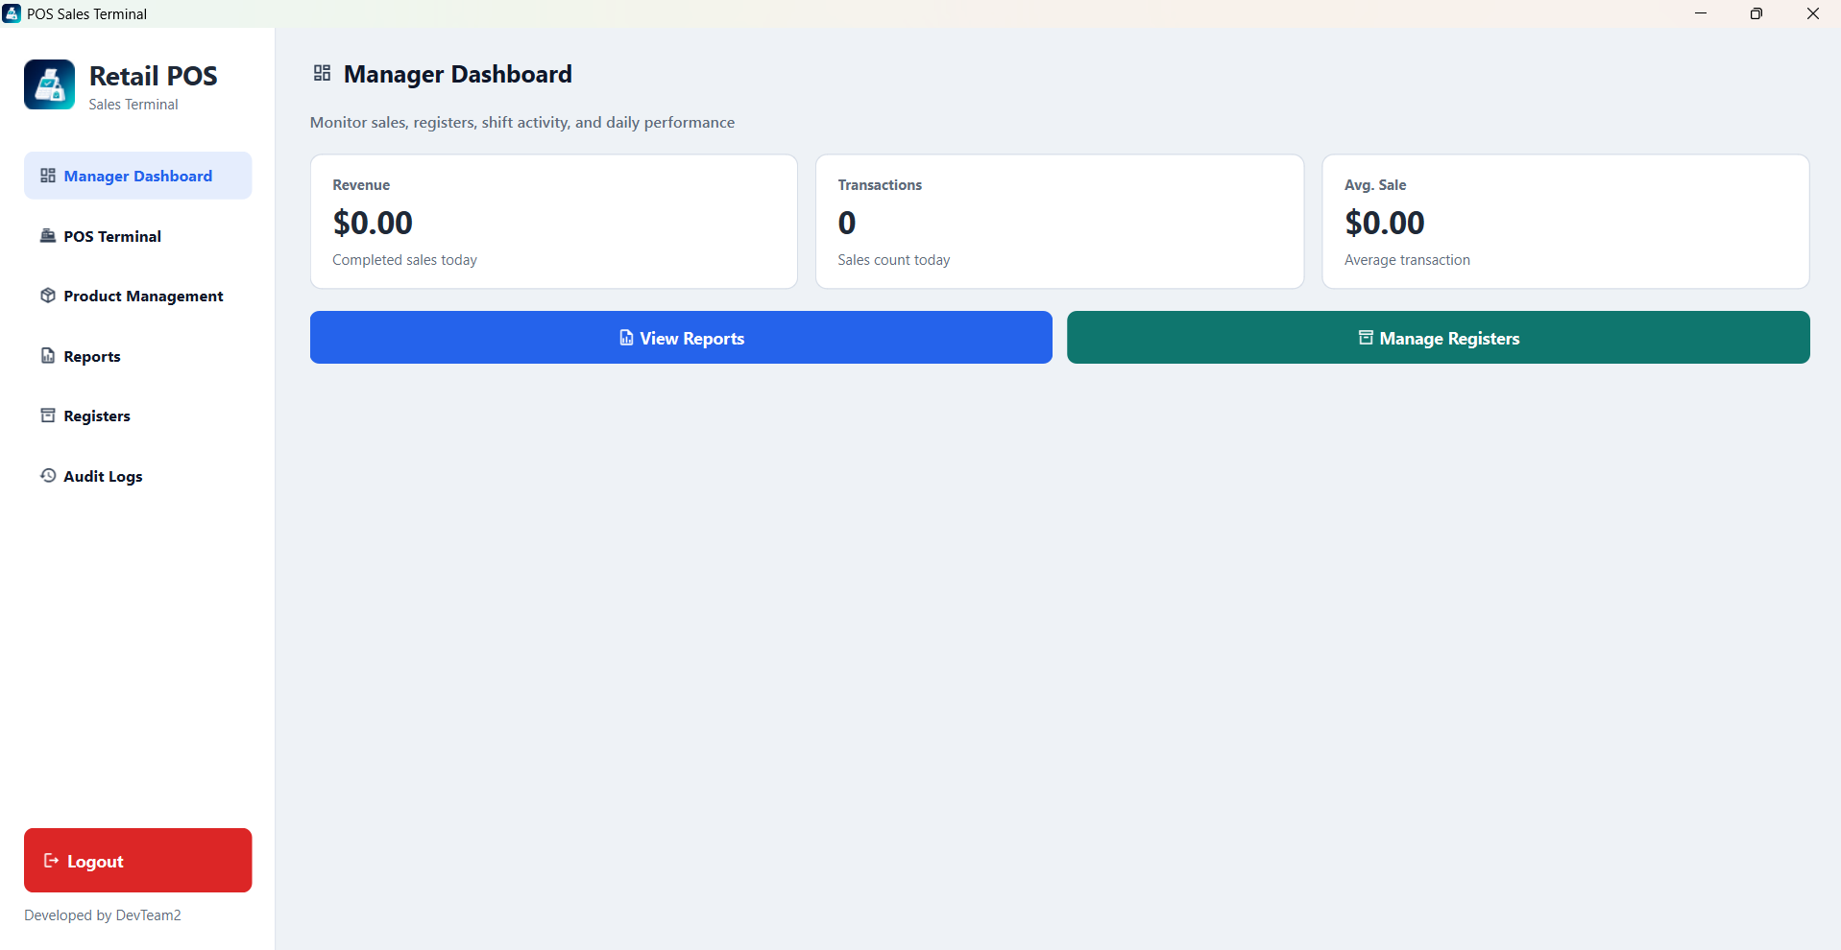

Figure 24: Manager’s Dashboard

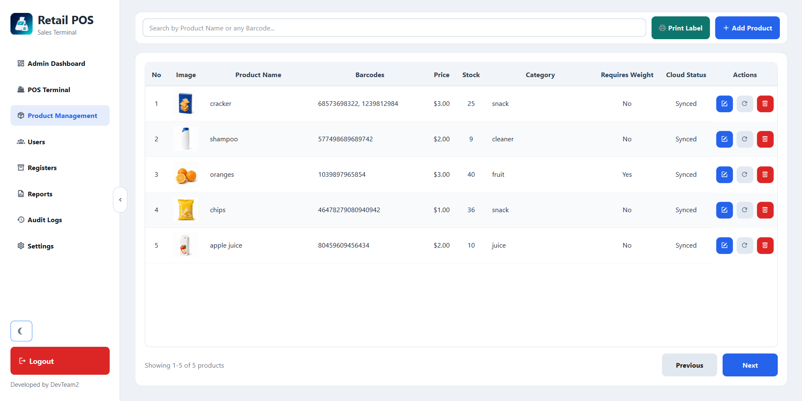Figure 25: Product Management

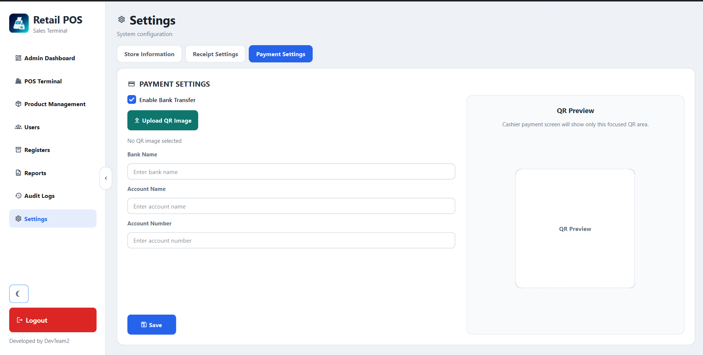

Figure 26: Settings

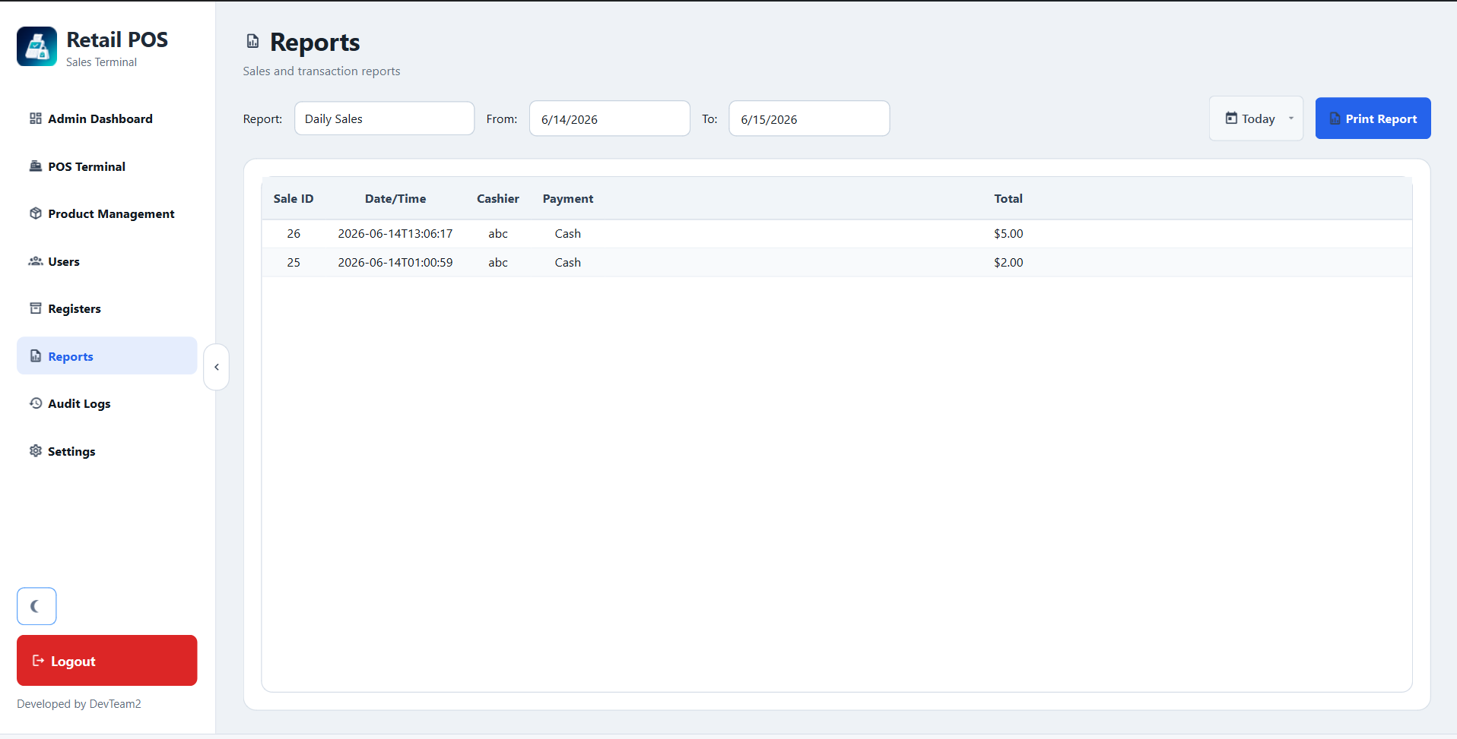

Figure 27: Reports

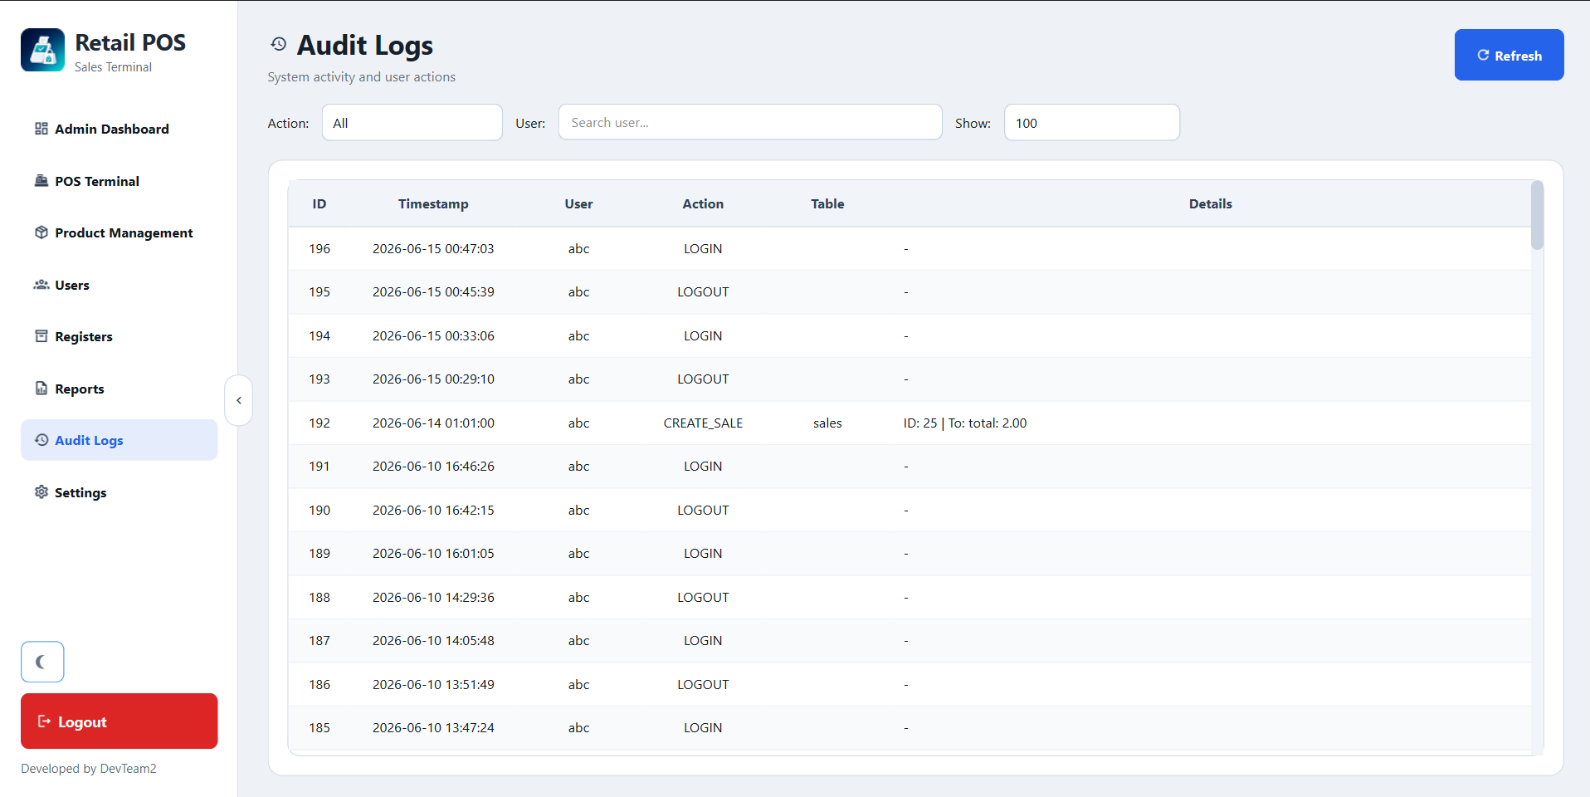

Figure 28: Audit Logs

Chapter Five

Testing and Evaluation

5.1 Introduction
Testing is an essential phase in the software development life cycle that ensures the reliability, functionality, and quality of the Retail Point of Sale (POS) System. The purpose of testing is to verify that all modules operate according to the specified requirements and that users can perform daily retail operations efficiently and securely.
The POS system was tested using multiple testing approaches including unit testing, integration testing, system testing, user acceptance testing, performance testing, and security testing. Testing focused on key business processes such as authentication, sales transactions, inventory management, payment processing, reporting, register operations, and cloud synchronization.
The objective of the testing process is to identify defects, validate system requirements, improve software stability, and ensure a satisfactory user experience before deployment.

5.2 Overview of Testing
The testing strategy was designed to evaluate both functional and non-functional requirements of the POS application.
Testing Scope:
- User authentication and role management
- Product management
- Inventory tracking
- Sales processing
- Receipt generation
- Payment processing
- Cash register management
- Shift management
- Reporting functions
- Audit logging
- Settings management
- Cloud synchronization
Testing Environment:
Item | Description
Operating System | Windows 10 / Windows 11
Development Language | Python
Framework | PyQt6
Database | SQLite
Cloud Backend | Supabase
IDE | Visual Studio Code
Testing Type | Manual + Functional Testing

5.3 Testing Concepts
The following testing methods were applied:
Functional Testing
Verifies that every feature performs according to system requirements.
Examples:
- Login authentication
- Product creation
- Sales processing
- Receipt printing
Integration Testing
Verifies communication between modules.
Examples:
- Sales module updating inventory
- Register module updating reports
- Cloud synchronization updating local records
System Testing
Evaluates the complete application.
User Acceptance Testing
Ensures the application satisfies end-user expectations.
Security Testing
Validates authentication, authorization, and access restrictions.
Performance Testing
Measures system responsiveness and stability under realistic workloads.

5.4 Test Cases

Table 5.4.1 Login Authentication
Test ID | Test Scenario | Input | Expected Result | Status
TC-001 | Valid Admin Login | admin/admin123 | Login successful | Pass
TC-002 | Valid Manager Login | manager/manager123 | Login successful | Pass
TC-003 | Valid Cashier Login | cashier/cashier123 | Login successful | Pass
TC-004 | Invalid Password | Wrong password | Error message displayed | Pass
TC-005 | Empty Credentials | Blank fields | Validation warning | Pass

Table 5.4.2 Product Management
Test ID | Test Scenario | Expected Result | Status
TC-006 | Add Product | Product saved successfully | Pass
TC-007 | Edit Product | Changes updated | Pass
TC-008 | Delete Product | Product removed | Pass
TC-009 | Add Barcode | Barcode saved | Pass
TC-010 | Upload Product Image | Image displayed correctly | Pass

Table 5.4.3 Sales Processing
Test ID | Test Scenario | Expected Result | Status
TC-011 | Add Item To Cart | Item appears in cart | Pass
TC-012 | Update Quantity | Total recalculated | Pass
TC-013 | Remove Item | Item removed | Pass
TC-014 | Complete Sale | Sale saved | Pass
TC-015 | Void Transaction | Transaction canceled | Pass

Table 5.4.4 Payment Processing
Test ID | Test Scenario | Expected Result | Status
TC-016 | Cash Payment | Payment completed | Pass
TC-017 | Bank Transfer Payment | QR displayed correctly | Pass
TC-018 | Split Payment | Sale completed successfully | Pass
TC-019 | Insufficient Cash | Warning displayed | Pass
TC-020 | Auto Receipt Print | Receipt generated | Pass

5.5 Testing Activities
Testing activities were conducted throughout development and included:
- Requirement Verification
- Test Planning
- Test Case Preparation
- Module Testing
- Bug Identification
- Bug Fix Verification
- Regression Testing
- User Acceptance Testing
- Final Validation
The testing process followed an iterative approach where defects were corrected and retested until successful completion.

5.6 Unit Testing
Unit Testing was conducted to verify that each individual module and function of the Retail Point of Sale (POS) System operates correctly in isolation before integration with other modules. The primary objective was to ensure that all core business functions, database operations, payment processing logic, inventory calculations, and authentication mechanisms perform accurately and consistently without relying on external modules.
The unit testing process focused mainly on the following modules:
• Authentication Module
• User and Role Management Module
• Product Management Module
• Inventory Management Module
• Sales Processing Module
• Payment Processing Module
• Receipt Generation Module
• Register Management Module
• Cash Shift Management Module
• Reporting Module
• Settings Management Module
• Cloud Synchronization Module
• Main POS Dashboard
• Login Window
The testing environment was designed to simulate real-world application usage while allowing each module to be tested independently. Unit tests were performed using both manual verification and controlled execution of application functions.
The testing tools and technologies included:
• Python Testing Environment
• PyQt6 Application Components
• SQLite Test Database
• Supabase Cloud Synchronization Testing
• Isolated Database Transactions
• Mock User Authentication Sessions
Each unit test followed a standardized testing structure consisting of:
• Test Input Data
• Expected Result
• Actual Result
• Test Status (Pass/Fail)
Unit testing played an important role in identifying logical errors, validation problems, calculation inaccuracies, and database interaction issues during the early stages of development. By validating each module independently, potential defects were resolved before proceeding to integration and system-level testing. This approach significantly improved software reliability, maintainability, and overall application quality.
- Input for frontend testing:
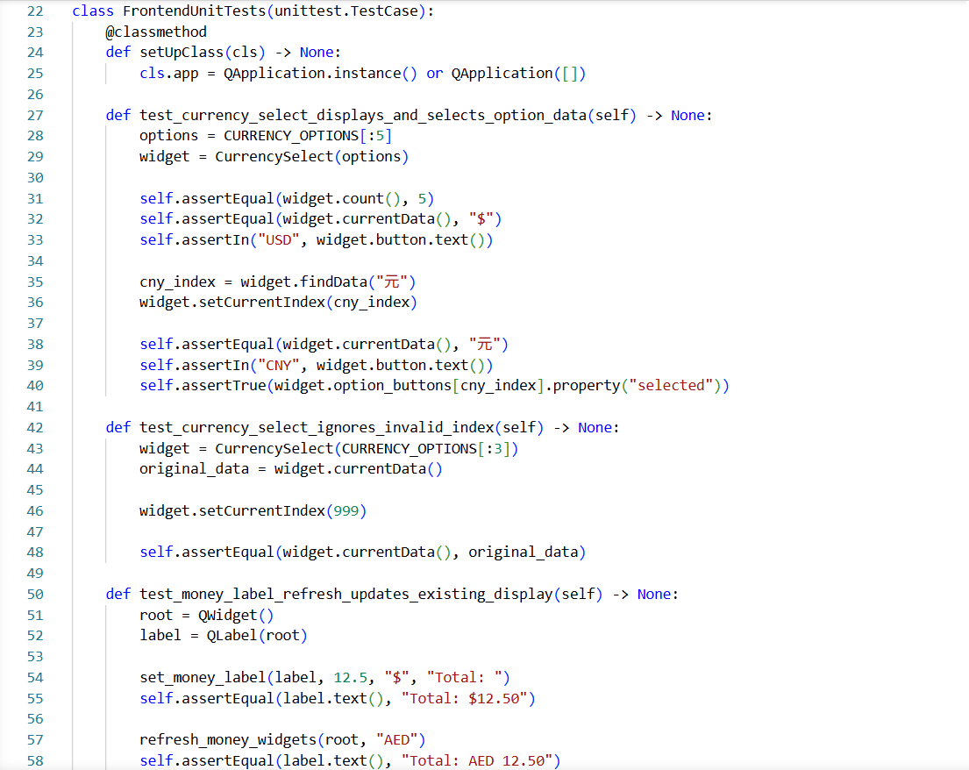

Figure 29

- Output of frontend testing:
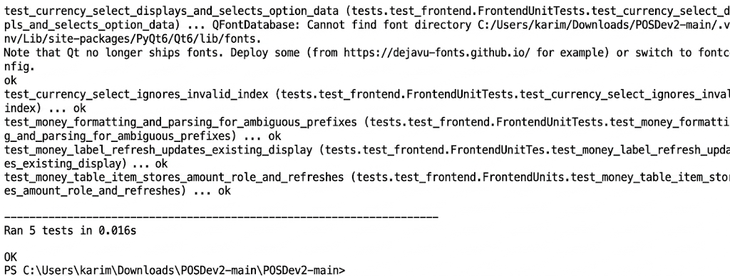

Figure 30

- input for backend testing:
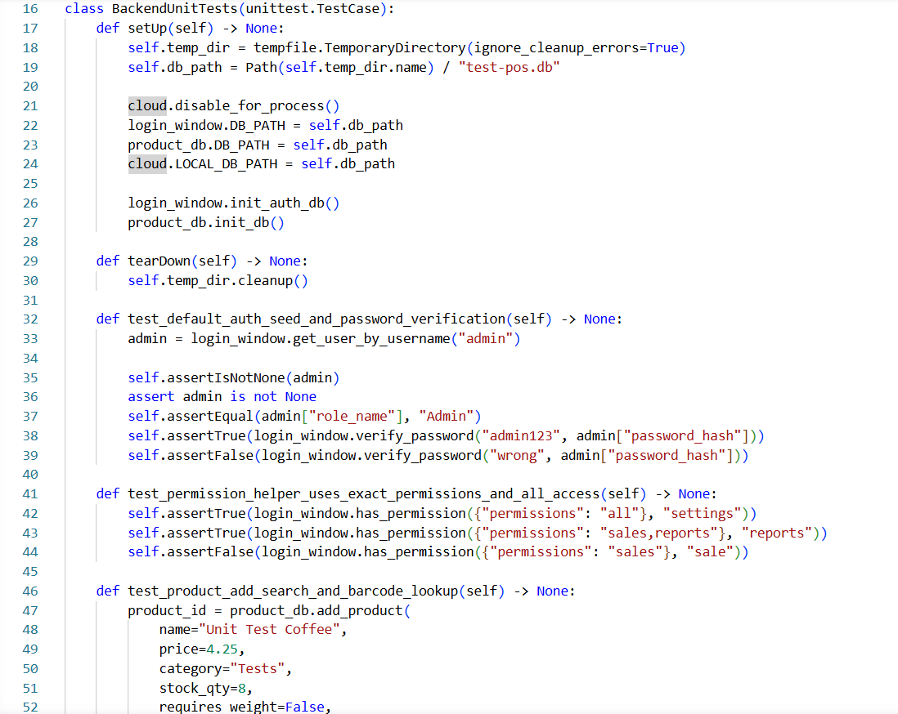

Figure 31

- Output of backend testing:
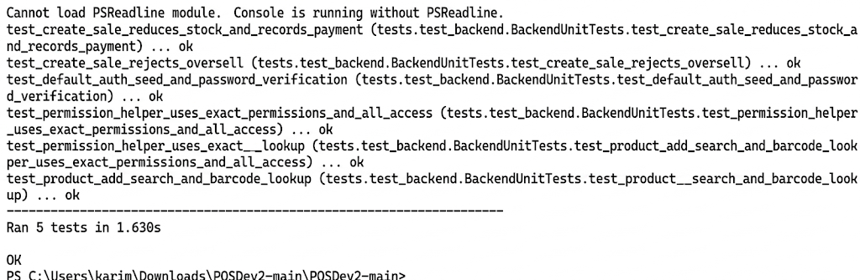

Figure 32

5.7 Integration Testing
Integration Testing was performed to verify the correct interaction between different modules of the Retail Point of Sale (POS) System after unit testing was successfully completed. The objective was to ensure that data flows correctly between the user interface, application logic, database, and cloud services.
User Interface – Application Integration:
Core features such as Login, Product Management, Sales Processing, Payment Handling, Reports, and Settings were tested through the PyQt6 interface to verify that user actions triggered the correct system operations.
Application – Database Integration:
All operations were tested using the SQLite database to confirm proper insertion, retrieval, updating, and deletion of records. Data consistency was verified across Products, Sales, Users, Payments, Registers, Shifts, and Audit Logs.
Sales – Inventory Integration:
Testing confirmed that completed sales automatically reduced product stock quantities and updated inventory records correctly. Voided transactions were also verified to ensure inventory accuracy.
Sales – Payment Integration:
Cash payments, bank transfers, and split payments were tested to verify that payment information was correctly linked to sales transactions and recorded in the database.

Reporting Integration:
Sales transactions were verified to ensure they appeared correctly in Daily Sales Reports, Sales by Cashier Reports, Shift Reports, and Payment Method Reports.
Cloud Synchronization Integration:
Integration testing verified that local changes were synchronized with Supabase when cloud connectivity was available. Offline transactions were stored in the Sync Queue and synchronized successfully when the connection was restored.
Role-Based Access Integration:
Testing confirmed that Admin, Manager, and Cashier roles could access only authorized system functions. Unauthorized access attempts were blocked successfully.
Integration testing confirmed that all POS modules functioned together as a complete and unified system with accurate communication between the user interface, business logic, database, and cloud synchronization components.
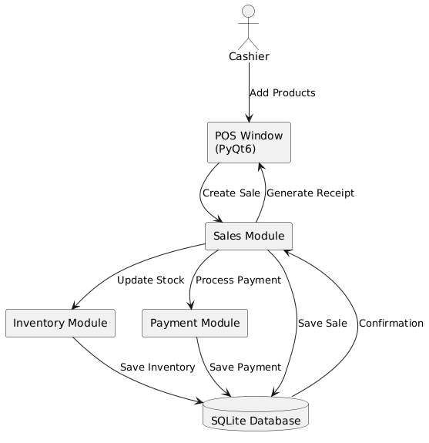

Figure 33

Figure 5.7: Integration Testing

5.8 System Testing
System Testing was conducted to validate the complete and fully integrated Retail Point of Sale (POS) System against all functional and non-functional requirements. This phase ensured that the entire application operated correctly as a single system in a real retail environment.
- Functional System Testing:
All core POS features were tested including:
• User authentication and role-based access control
• Product and inventory management
• Product search and barcode scanning
• Sales transaction processing
• Cash, bank transfer, and split payment methods
• Receipt generation and printing
• Register and cash shift management
• Sales reporting and analytics
• Audit logging and user management
• Cloud synchronization and offline operation
Each feature was tested using realistic retail scenarios to ensure accurate results, proper data processing, and stable system behavior.
- Non-Functional System Testing:
Performance Testing: The performance test checks how fast the POS backend works.
It uses a temporary copy of the database, so the real pos.db is not changed.
The script tests common POS actions:
- Load products
- Search products
- Scan barcode
- Add product
- Create sale
- Run sales report query
Each action runs many times.
The script measures:
- Minimum time
- Average time
- Median time
- Maximum time
If the median time is under the limit, the test passes.
All tested operations passed successfully.
- Testing input:
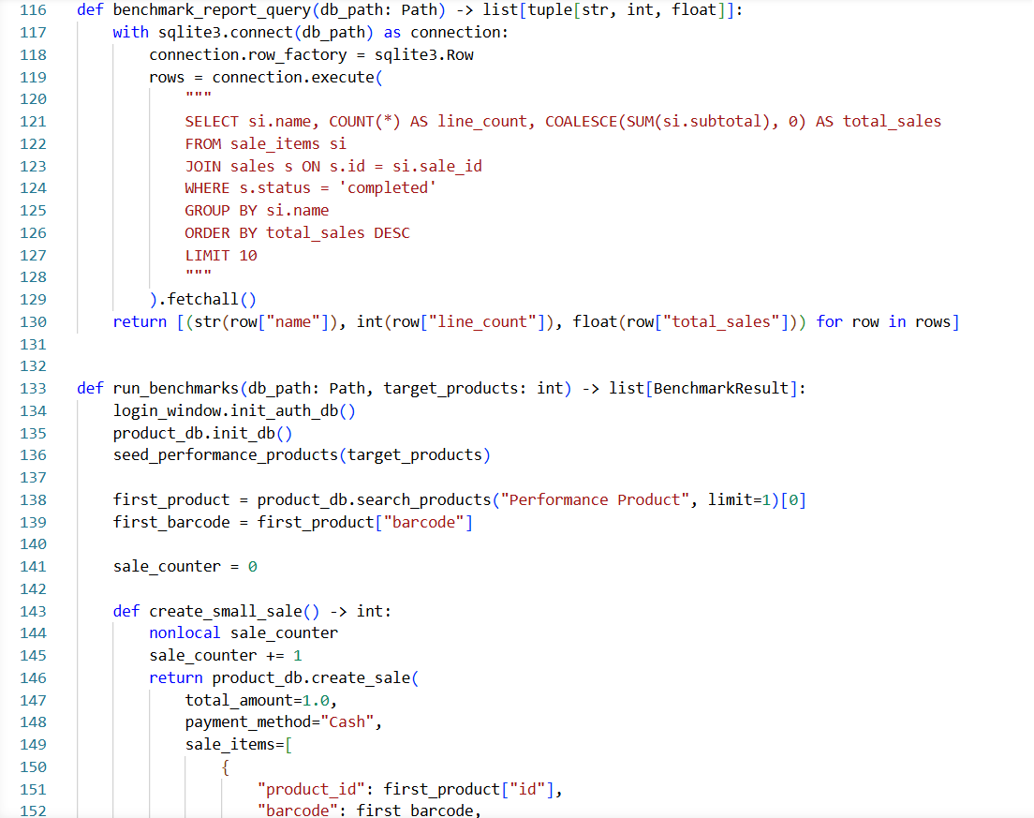

Figure 34

- Testing output:
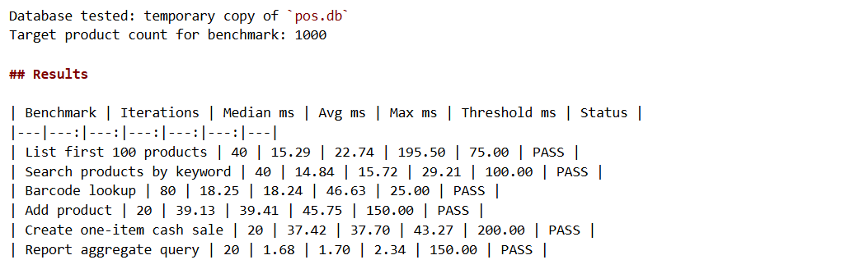
- Testing Results:
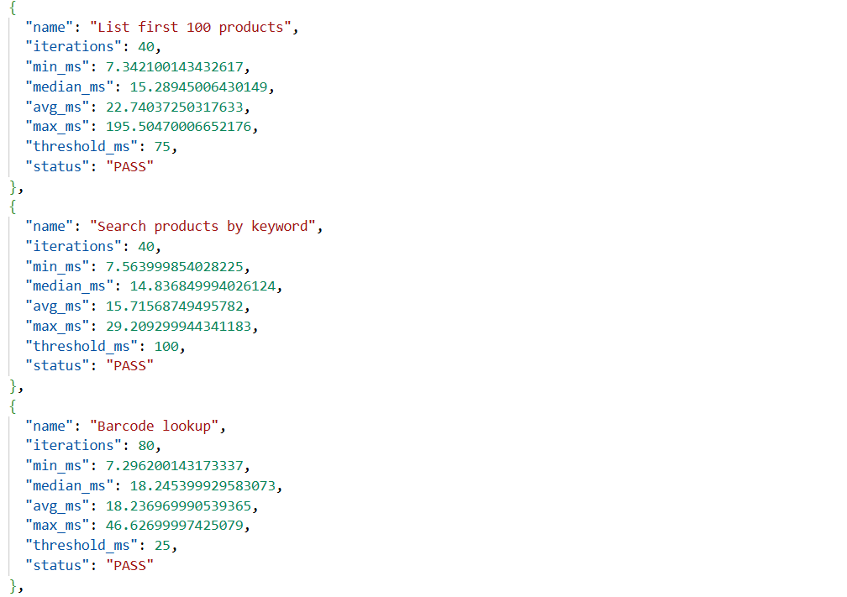

Figure 35

Security Testing: The security test checks common risks in the POS app.
It uses a temporary copy of the database, so the real data is not changed.
The script tests:
- Login SQL injection
- Wrong password rejection
- Password storage behavior
- Default active accounts
- User permission checks
- Duplicate usernames
- Invalid user roles
- Product price validation
- Duplicate barcodes
- Overselling stock
- Unknown barcode sales
- Negative sale totals
- Settings protection
- .env file safety

- Test Input:
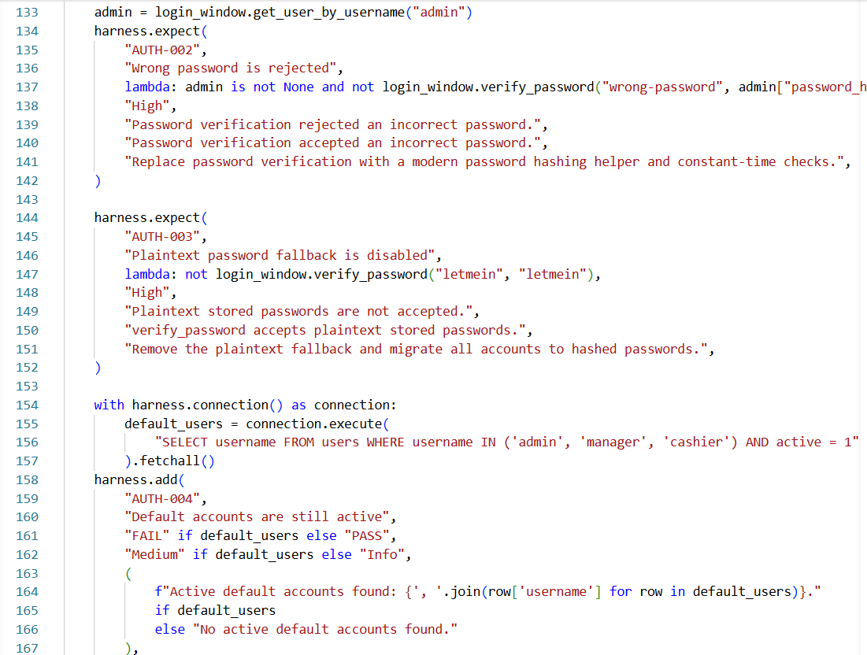

Figure 36

- Test Output:
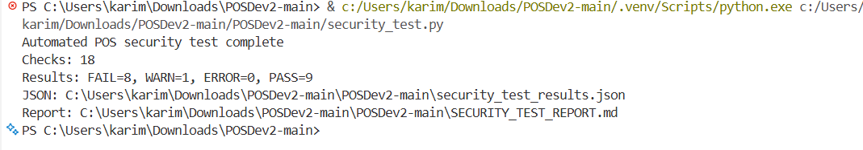

Figure 37
- Test Results:
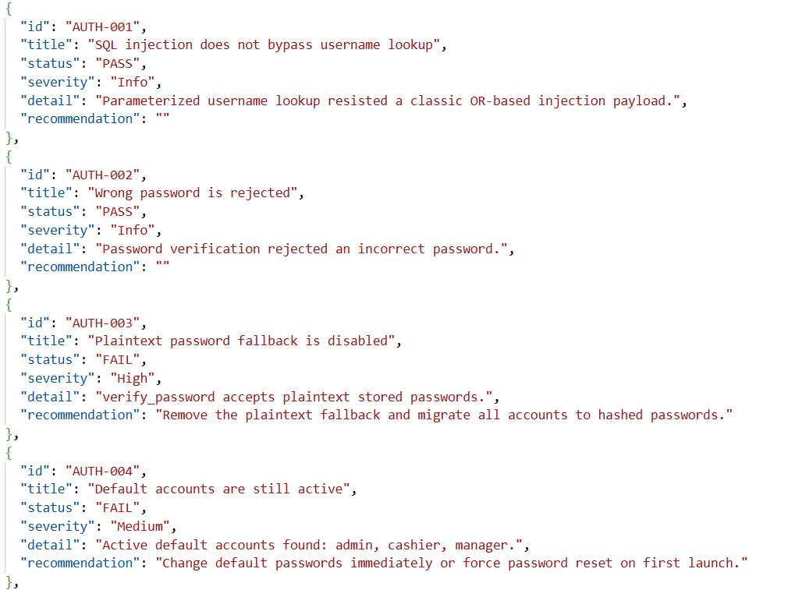

Figure 38

Main risks found:
- Plaintext password fallback exists
- Default accounts are still active
- Invalid roles can be saved
- Negative sale totals can be created
- Some inputs need stronger validation

Reliability Testing: The reliability test checks if the POS app stays stable during repeated use.
It uses a temporary copy of the database, so the real data is not changed.
The script tests:
- Repeated database initialization
- Repeated product loading
- Repeated product search
- Repeated barcode lookup
- Repeated invalid sale rejection
- Concurrent product reads
- Stock consistency after failed sales
- Multiple valid sales

- Test Input:
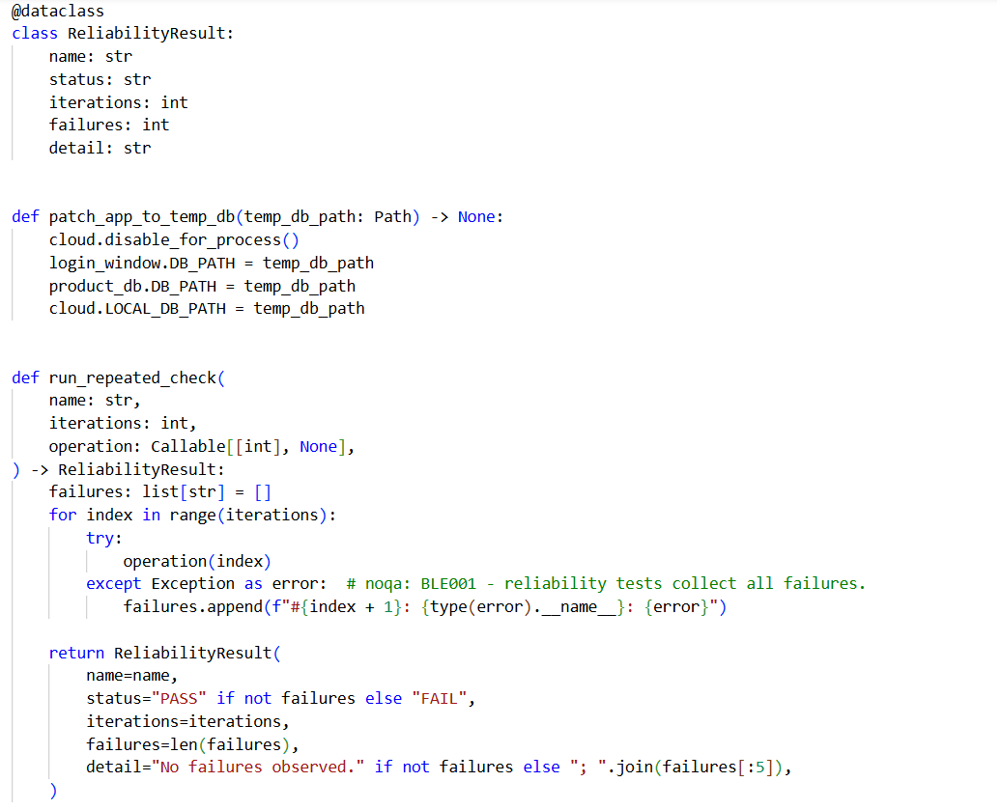

Figure 39

- Test Output:
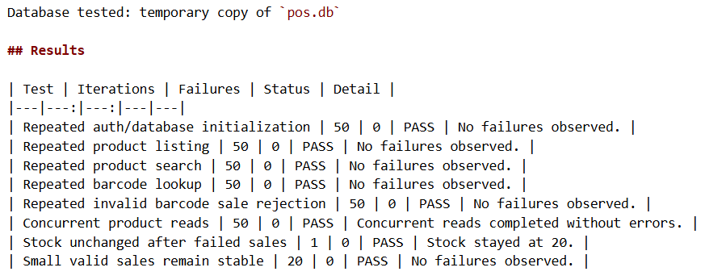

Figure 40

- Test Results:
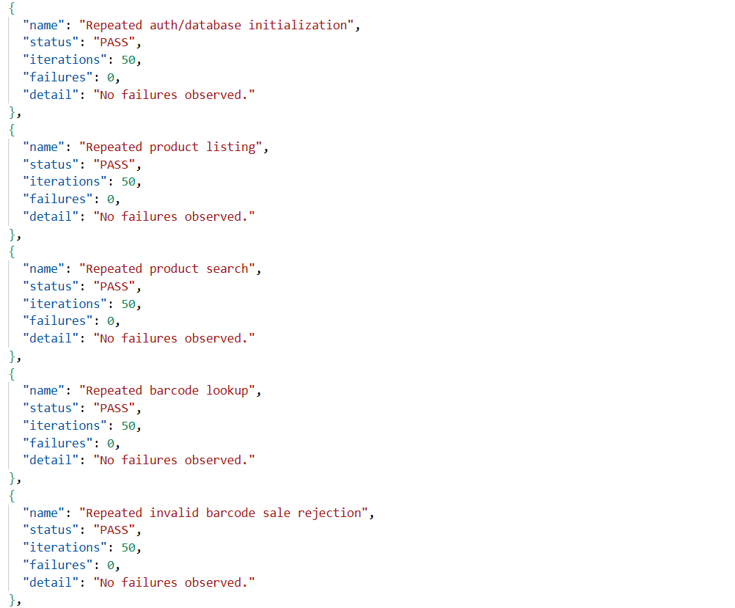

Figure 41
The test ran 8 checks.
Result:
- 8 passed
- 0 failed
This shows that the main backend operations stayed stable during repeated use.

Usability Testing: The usability test checks if the POS app is easy and clear to use.
It tests important interface elements such as:
- Login form placeholders
- Password hiding by default
- Role dropdown
- Login button text
- Settings tabs
- Store form placeholders
- Receipt text fields
- Payment QR preview size
- Save and upload buttons
- Currency dropdown
- Money formatting
- Keyboard shortcuts
- Checkout action buttons

- Test Input:
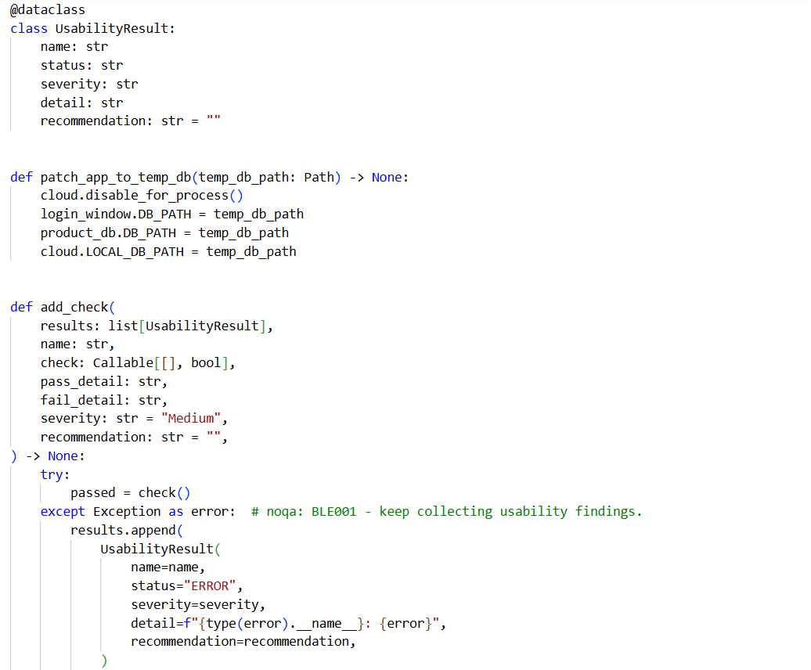

Figure 42

- Test Output:
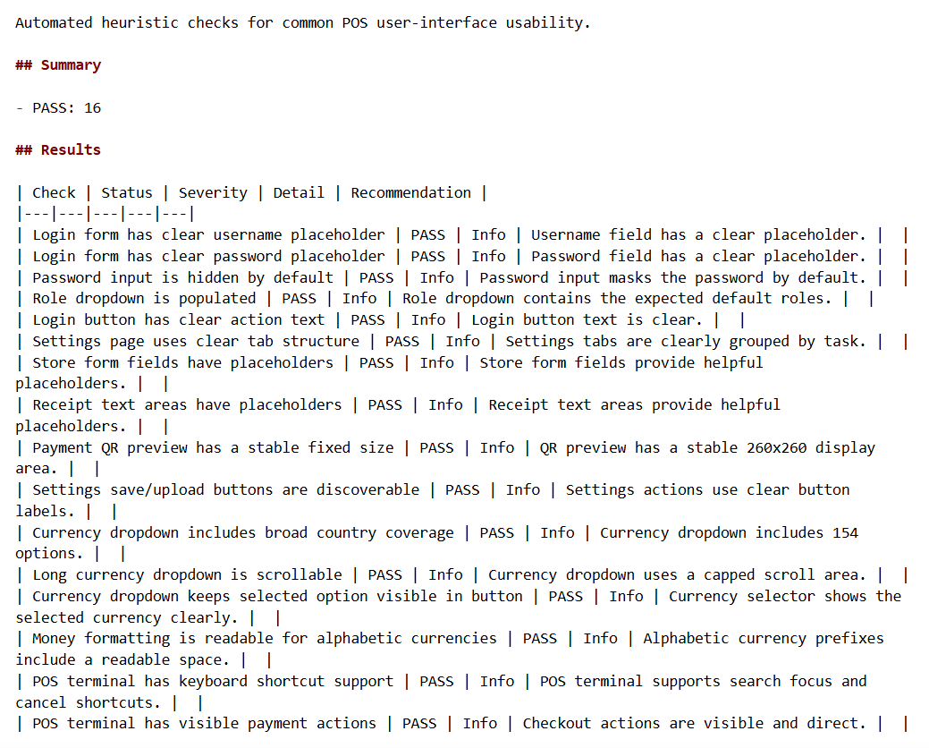

Figure 43

- Test Results:
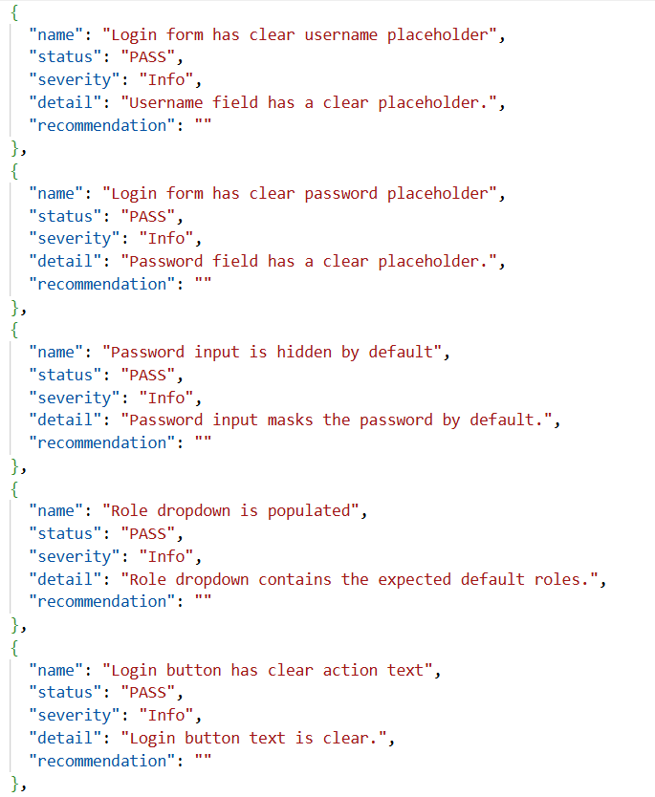

Figure 44
The test ran 16 checks.
Result:
- 16 passed
- 0 failed
This shows that the main POS interface is clear, organized, and easy to understand for users.
Compatibility Testing: The compatibility test checks if the POS app works correctly with the current system environment.
It tests:
- Python version
- Windows operating system
- Virtual environment
- Required packages
- PyQt6 startup
- SQLite database structure
- Main app module imports
- Required folders
- Required assets
- Test Input:
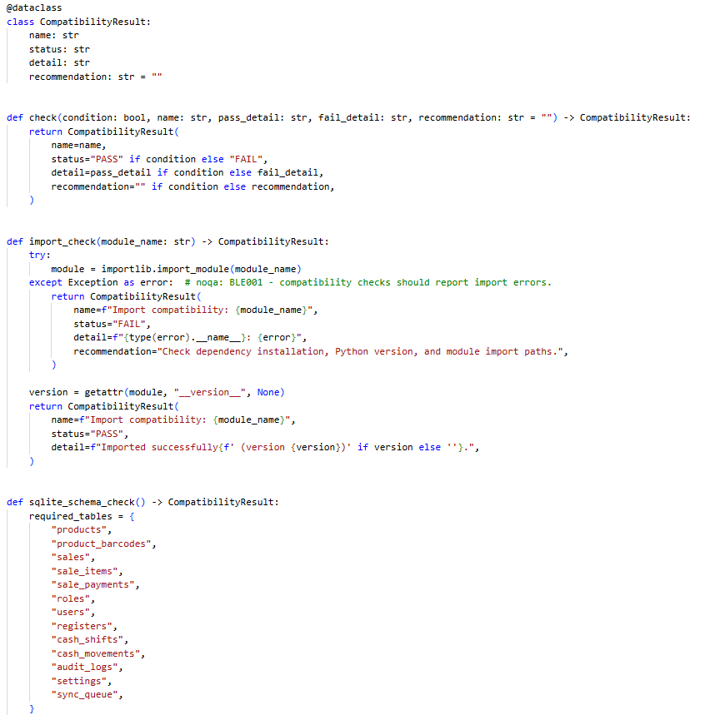

Figure 45

- Test Output:
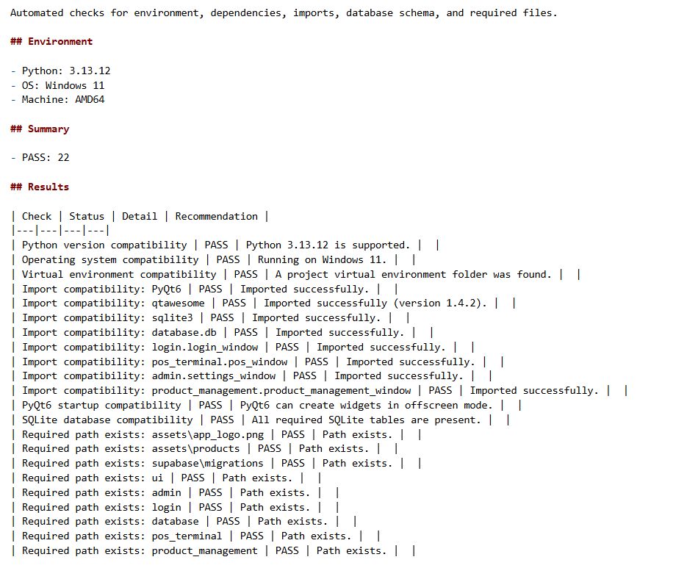

Figure 46
- Test Results:
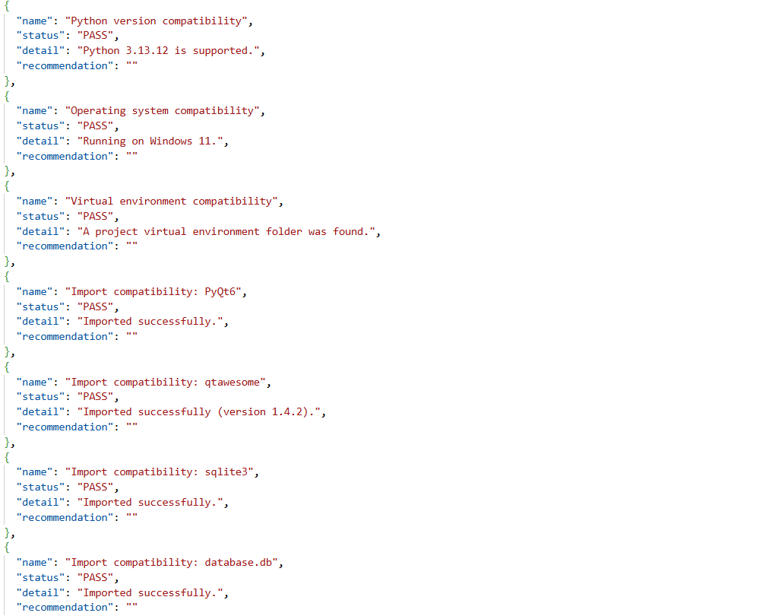

Figure 47

Offline support testing: The offline support test checks if the POS app can still work without an internet connection or cloud access.
It uses a temporary copy of the database, so the real data is not changed.
The test checks:
- Cloud mode disabled
- Local product loading
- Local product search
- Offline product creation
- Offline product saved in local database
- Offline sale creation
- Offline sale saved locally
- Stock update after offline sale
- Offline sync queue creation
- Safe sync behavior when cloud is unavailable
- Test Input:
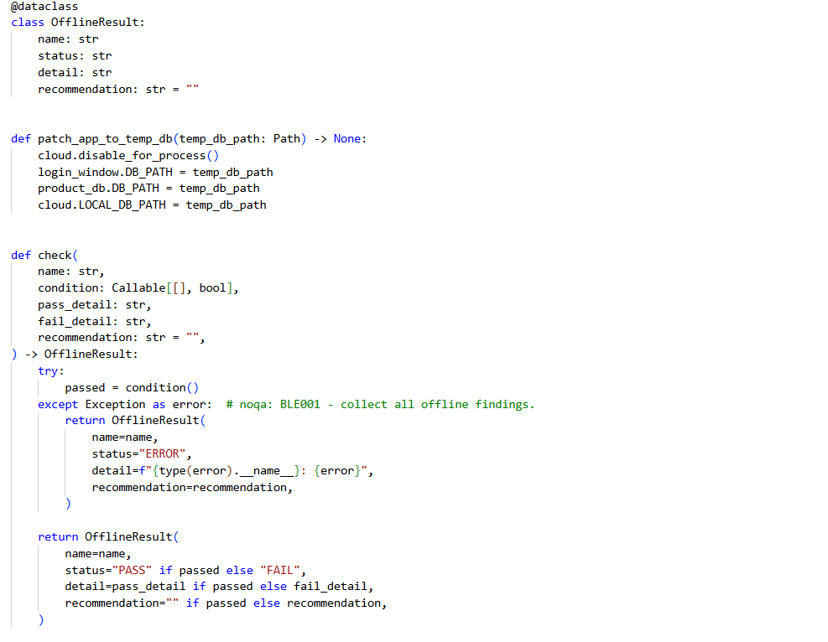

Figure 48

- Test Output:
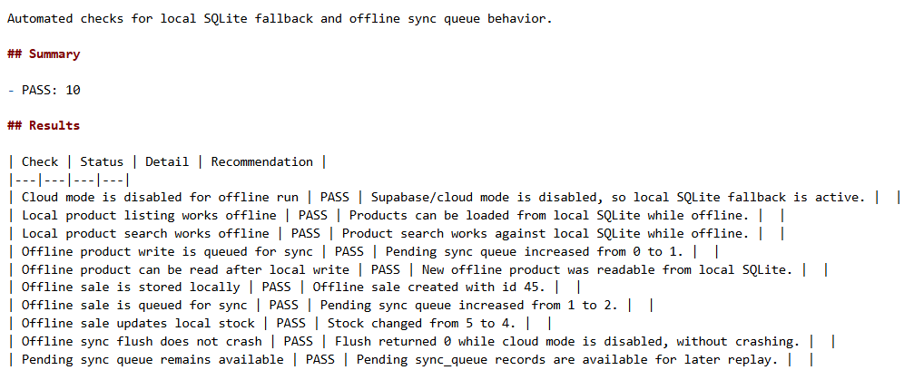

Figure 49

- Test Results:
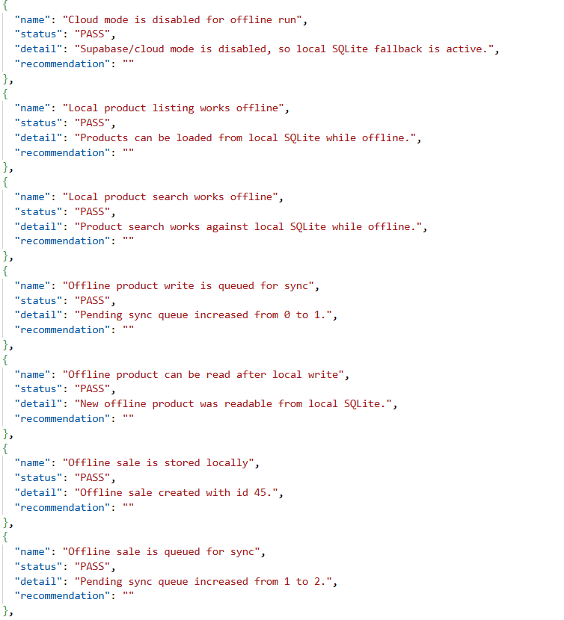

Figure 50

The test ran 10 checks.
Result:
- 10 passed
- 0 failed
This shows that the app can continue working offline and save changes locally until sync is available again.

Cloud sync Testing: It checks offline operation queueing, product sync payloads, successful queue flush behavior, failed sync retry/error handling, sale replay payload completeness, safe behavior when cloud is unavailable, and pending rows staying available for later sync.
The cloud sync test checks if the POS app can correctly save offline changes and sync them later.
It tests:
- Offline operation added to sync queue
- Product sync sends product data and barcodes
- Successful sync marks queue item as synced
- Failed sync keeps item pending
- Failed sync stores retry/error information
- Sale sync payload includes sale, items, and payments
- Sync does not crash when cloud is unavailable
- Pending items remain available for future sync

- Test Input:
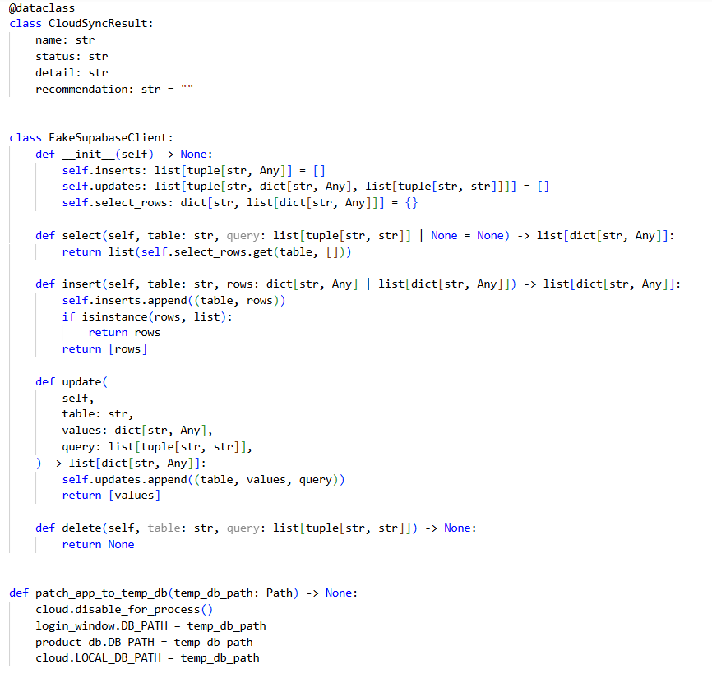

Figure 51

- Test Output:
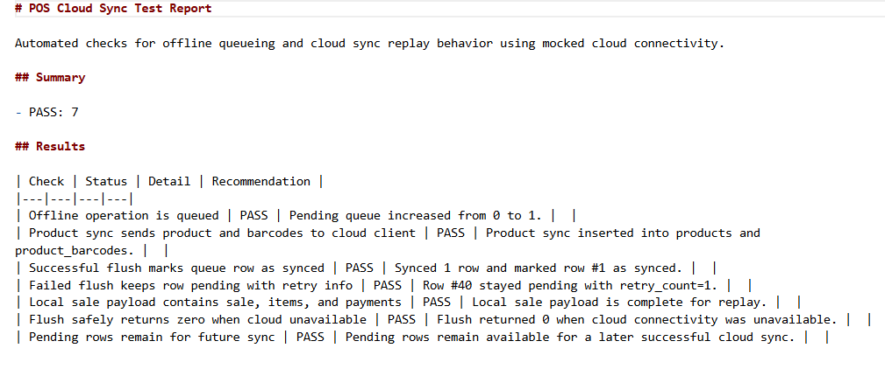

Figure 52
- Test Results:
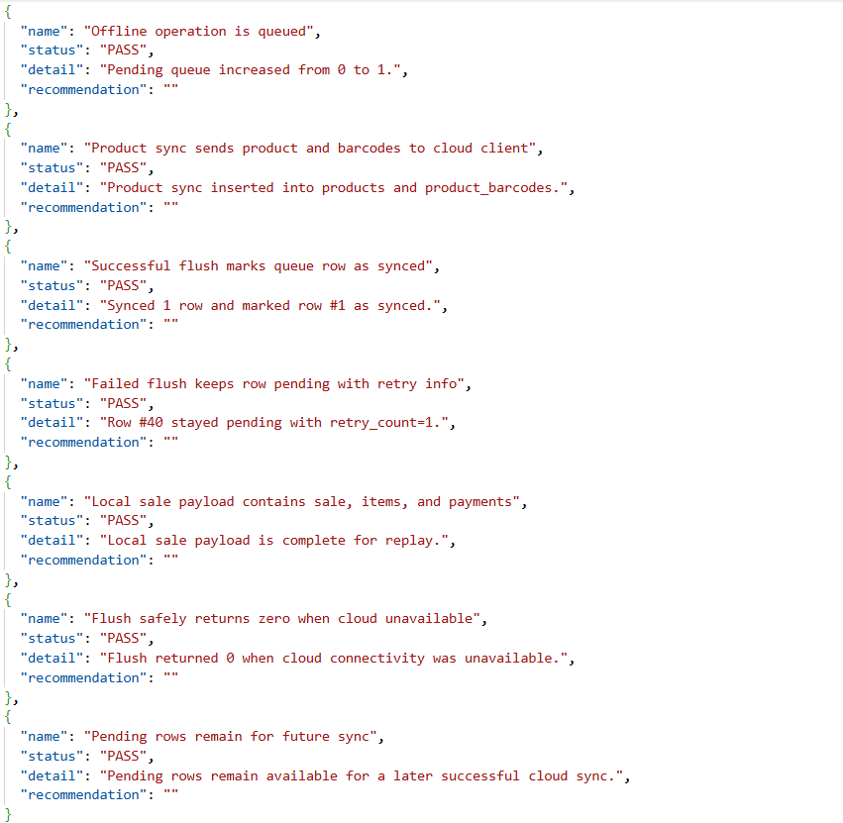

Figure 53

The test ran 7 checks.
Result:
- 7 passed
- 0 failed
This shows that the cloud sync system can queue offline work, handle successful sync, and safely keep failed items for retry later.

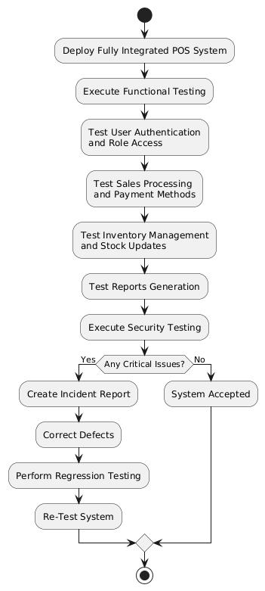

Figure 54: System Testing

5.9 User Acceptance Testing
Acceptance Testing was performed to ensure that the Retail Point of Sale (POS) System meets the actual requirements of retail store staff before final deployment.
- User Acceptance Testing (UAT):
Real retail operation scenarios were tested by users assigned to each role:
• Admins: User management, system settings, inventory control, and sales monitoring
• Managers: Product management, sales reports, shift management, and reconciliation
• Cashiers: Product search, barcode scanning, sales processing, payment handling, and receipt printing
Users verified that the system was easy to use, accurate, and aligned with daily retail operations. Common business activities such as completing sales, managing inventory, generating reports, and handling payments were performed successfully.
- Client Approval Testing:
The complete POS solution was demonstrated using real sales and inventory data simulations. Core features including authentication, product management, checkout processing, cash and bank transfer payments, reporting, and shift management were evaluated.
Feedback was collected from users, minor interface improvements were implemented, and the final system was approved for deployment.
Acceptance testing confirmed that the POS System fulfills all functional, usability, and operational requirements expected in a modern retail environment.

5.10 The POS Testing Pyramid:
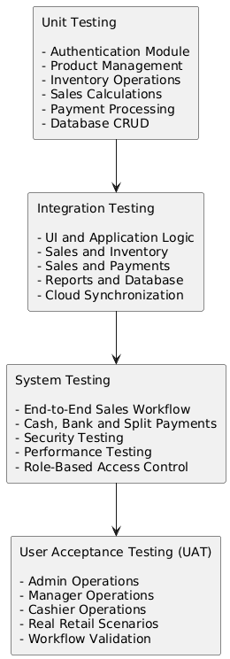

Figure 55: POS Testing Pyramid

5.11 Regression Testing
Regression Testing was conducted after each major feature implementation, bug fix, and system update to ensure that modifications did not negatively affect existing functionalities of the Retail Point of Sale (POS) System.
- Regression testing was performed to revalidate:
• Login and Authentication
• Product Management and Inventory Operations
• Sales Processing and Cart Calculations
• Cash, Bank Transfer, and Split Payment Methods
• Receipt Generation and Printing
• Reports and Analytics
• Register and Cash Shift Management
• Role-Based Access Control
• Cloud Synchronization Functions
- Manual regression tests were also executed for critical retail workflows:
• Complete Sales Transaction Workflow
• Product Search and Barcode Scanning
• Inventory Updates After Sales
• Shift Opening and Closing Procedures
• Sales Reporting and Reconciliation
• Offline and Online Synchronization Operations
This testing ensured that newly implemented features and resolved defects did not introduce additional issues into previously stable modules. All critical business processes continued to operate correctly after system updates, confirming the stability and reliability of the POS system.

5.12 Test Incident Reporting:
Bug ID | Severity | Description | Status
BUG-01 | High | Sales transaction not reflected immediately in reports module | Fixed
BUG-02 | High | Cloud synchronization failed when reconnecting after offline mode | Fixed
BUG-03 | Medium | Product image not displayed after editing product information | Fixed
BUG-04 | Low | UI alignment issue in checkout and payment panel | Fixed
BUG-05 | Critical | Unauthorized role access detected for protected administrative features | Fixed

5.13 Additional Test Cases
The testing process was conducted to evaluate the functionality, stability, and reliability of the POS system under different operational scenarios. The system was tested using manual testing methods to verify that all major operations work correctly and consistently.
Test ID | Test Description | Test Input / Action | Expected Result | Actual Result | Status
TC-01 | User Login Authentication | Enter valid username and password | User successfully logs into the system | Login completed successfully | Passed
TC-02 | Invalid Login Validation | Enter incorrect username or password | System displays warning message | Warning message displayed correctly | Passed
TC-03 | Session Persistence | Enable “Keep Me Logged In” and restart application | User session remains active | Session restored successfully | Passed
TC-04 | Product Search Function | Search product using barcode or product name | Correct product displayed instantly | Product displayed correctly | Passed
TC-05 | Add Product to Cart | Select product from product list | Product added into cart | Product added successfully | Passed
TC-06 | Repeated Barcode Scan | Scan same barcode multiple times | Product quantity increases automatically | Quantity updated correctly | Passed
TC-07 | Quantity Update Validation | Increase and decrease product quantity | Cart updates accurately | Quantity updated successfully | Passed
TC-08 | Stock Availability Validation | Attempt to sell out-of-stock item | System prevents invalid sale | Warning displayed correctly | Passed
TC-09 | Cash Payment Processing | Complete transaction using cash payment | Sale processed successfully | Payment completed successfully | Passed
TC-10 | Bank Transfer Payment | Select bank transfer payment method | QR and bank details displayed | Payment information shown correctly | Passed
TC-11 | Split Payment Function | Use multiple payment methods in one transaction | System accepts split payment | Transaction processed correctly | Passed
TC-12 | Receipt Preview Generation | Complete payment successfully | Receipt preview displayed | Receipt generated correctly | Passed
TC-13 | Sales Record Storage | Finish transaction process | Sales data saved into database | Database updated successfully | Passed
TC-14 | Payment Record Validation | Complete payment transaction | Payment information stored correctly | Payment data saved successfully | Passed
TC-15 | Product Information Management | Add or edit product information | Product details updated in system | Product updated successfully | Passed
TC-16 | Product Image Upload | Upload image for product | Product image displayed correctly | Image uploaded successfully | Passed
TC-17 | Multiple Barcode Support | Assign multiple barcodes to one product | Product searchable by all barcodes | Function worked correctly | Passed
TC-18 | Role-Based Access Control | Login using different user roles | Appropriate dashboard displayed | Access permissions worked correctly | Passed
TC-19 | Report Generation | Generate sales report | Report displayed accurately | Report generated successfully | Passed
TC-20 | Logout Functionality | Logout from system | User session terminated securely | Logout completed successfully | Passed

5.14 System Performance
The POS system demonstrated stable and responsive performance during testing. The application was developed using PyQt6 and SQLite, allowing it to run efficiently on standard desktop computers without requiring high-end hardware.
Performance Evaluation
- The login process responds quickly and loads the appropriate dashboard based on user roles.
- Product searching using barcode or product name is fast and accurate.
- The cart system updates product quantities in real time without noticeable delay.
- Database transactions such as sales recording and stock updates are processed successfully.
- Receipt generation and payment confirmation are completed smoothly.
- The interface remains responsive while navigating between modules.
Strengths of the System
- Lightweight desktop application with offline capability.
- Efficient quantity-based inventory management.
- Role-based access improves security and usability.
- Integrated payment methods including split payment and bank transfer.
- Persistent session support improves user experience.
Overall, the system achieved stable performance and successfully fulfilled the objectives of a desktop retail POS prototype.

5.15 Challenges
Several challenges were encountered during the development and testing of the POS system.
User Interface Design
Creating a clean and user-friendly interface in PyQt6 required multiple design adjustments. Balancing product display, shopping cart layout, and payment sections while maintaining usability was challenging.
Inventory Management
Managing stock quantities accurately was one of the most critical challenges. The system needed to prevent invalid sales, support repeated barcode scans, and maintain real-time stock updates.
Payment Integration
Implementing split payment and bank transfer workflows required additional logic to handle multiple payment methods while ensuring accurate sales recording.
Database Structure
Designing a database structure capable of handling products, barcodes, payments, reports, and audit logs required careful planning to maintain data consistency and avoid redundancy.
Role-Based Access Control
Different user roles such as Admin, Manager, and Cashier required separate permissions and navigation systems, increasing development complexity.
Performance Optimization
The application required optimization to ensure smooth operation when handling large product lists and multiple interface updates simultaneously.

5.16 Conclusion
In conclusion, the POS system successfully achieved its main objectives by providing a functional and reliable desktop-based retail management solution. The system supports essential retail operations including authentication, inventory management, payment processing, reporting, and product management.
The project demonstrates how PyQt6 and SQLite can be combined to create a modern desktop application with an organized interface and persistent database functionality. Features such as split payment, multiple barcode support, role-based access, and receipt preview enhance the practicality of the system.
This project improved understanding of desktop application development, database management, UI design, and software testing processes.

5.17 Future Work
Several improvements can be implemented in future versions to enhance the system further.
Planned Improvements
- Add refund and return management system.
- Implement PDF receipt export.
- Develop inventory adjustment functionality.
- Add product category management.
- Create automated testing for system validation.
- Add tax and Value Added Tax calculation support.
- Improve database migration and version management.
- Enhance UI design for a more modern retail experience.
- Add customer loyalty and membership features.
Future development will focus on improving scalability, security, and user experience to make the system more suitable for real-world commercial environments.

Chapter Six

Individual Contribution and Self-Assessment

6.1. Student Name
1. TRUONG QUANG NGHIA (4420230904)
2. KARIM OUSSAMA (4420230906)
3. FRIMPONG MAAME ACHIAA (4420230903)

6.1.1. Role
# | Name | Student ID | Role
1 | TRUONG QUANG NGHIA | 4420230904 | Backend Developer and Database/Cloud Sync Integration (with UI/UX and Testing support
2 | KARIM OUSSAMA | 4420230906 | Team Manager, Frontend, Backend, Tester
3 | FRIMPONG MAAME ACHIAA | 4420230903 | System Designer, System Architecture and Documentation Lead

6.1.2. Task Completed
Member 1’s Contribution
Field | Details
Full Name | TRUONG QUANG NGHIA
Student ID | 4420230904
Role | Backend Developer and Database/Cloud Sync Integration (with UI/UX and Testing support

Task Module | Specific Work Done
Database Layer | Designed schema, implemented db.py, created all CRUD operations
Authentication Module | Built login system, password hashing, role-based permissions
POS Terminal | Created PosMain Window, cart management, product grid
Payment Processing | Implemented cash and split payment dialogs
Admin/Manager Modules | Created user management BE, setting store information, Receipt Setting, Payment Setting.
Online Sync | Implemented command queue and sync manager
Product Management | Created Product, Print Label, Add product, Action
Other | Dark mode, Register

Member 2’s Contribution
Field | Details
Full Name | KARIM OUSSAMA
Student ID | 4420230906
Role | Team Manager, Frontend, Backend, Tester

Task Module | Specific Work Done
Admin/Manager Modules | Created user management UI, Admin/Manager Dashborad, Register Manager.
Cashier Modules | Cashier side
Reporting | Built sales reports and shift summaries
Testing | Wrote unit, integration, and acceptance tests
Other | Login Ui, Fix UI, currency, Product Management UI,

Member 3’s Contribution
Field | Details
Full Name | FRIMPONG MAAME ACHIAA
Student ID | 4420230903
Role | System Designer, System Architecture and Documentation Lead

Task Module | Specific Work Done | Completion (%)
Documentation | Wrote system design, architecture, and user manual | 100%

6.1.3. Contribution Percentage
Name | Contribution Percentage
TRUONG QUANG NGHIA | 37.5%
KARIM OUSSAMA | 37.5%
FRIMPONG MAAME ACHIAA | 25%

6.1.4. Challenges
During the development of the CloudPOS system, the team encountered several technical, logistical, and coordination challenges. This document outlines the major difficulties faced and the solutions implemented to overcome them.

Challenge | Description | Impact | Solution
Offline Sync Complexity | Implementing reliable offline-first synchronization with conflict resolution was more complex than anticipated | Sales could be lost if sync failed | Implemented command queue pattern with retry logic (max 3 attempts). Used FIFO order with cloud-wins for products, local-wins for sales
Split Payment Logic | Handling multiple payment methods in one transaction with change calculation | Payment errors possible | Created separate payment processor class; tested 20+ split payment scenarios
Receipt Formatting | Generating properly formatted PDF receipts with dynamic content | Receipts looked misaligned | Used fixed-width font (Consolas); implemented string centering and padding functions
Weighted Products | Supporting variable quantity products (e.g., rice sold by kg) | Incorrect inventory tracking | Added requires_weight flag; implemented QInputDialog for weight entry
Database Row Level Security (RLS) | Implementing proper RLS policies for 3 user roles was complex | Risk of unauthorized data access | Researched Supabase RLS documentation; implemented role-based policies with extensive testing

6.1.5. Skills Gained
Throughout the development of the CloudPOS system, all three team members acquired and strengthened various technical and soft skills. This document outlines the key skills gained during the project.

1. Technical Skills Summary
Skill Category | Specific Skills | Team Member
Programming | Python 3.12 | All
GUI Development | PyQt6 | Member 1, 2
Database | SQLite, Supabase | Member 1,2
Authentication | Password hashing, bcrypt, session management | Member 1, 2
Testing | Unit testing, integration testing, system testing | Member 1, 2
Version Control | Git, GitHub, branching, merging | All
Documentation | Technical writing, UML diagrams | Member 3
Project Management | Gantt charts, WBS, CPM analysis | Member 3

6.1.6. Reflection
Member 1’s Reflection
Name: TRUONG QUANG NGHIA
Role: Backend Developer and Database/Cloud Sync Integration (with UI/UX and Testing support

What I Learned
Through this project, I learned how to build a desktop POS application using Python and PyQt6, combining SQLite as a local database and Supabase as the primary cloud data source. I gained a deeper understanding of multi-store data management using store_id, local-to-cloud data synchronization, user authentication, role-based access control, as well as product, inventory, invoice, and report management. Additionally, I acquired practical experience in working with GitHub, database migrations, real-time synchronization, and debugging during the transition from development to production environments.

What Went Well
The team successfully implemented core functionalities of the POS system, including login, product management, user management, checkout, reporting, inventory tracking, and Supabase data synchronization. The application's interface was progressively enhanced to be more user-friendly, particularly the POS screen, login/register, and user management modules. By adopting a cloud-first approach for the checkout process, we ensured greater stability for sales and inventory data. Furthermore, the team successfully resolved critical bugs related to barcode scanning, inventory, local/cached data, and multi-device synchronization.
What Could Have Been Better
Given more time, the team should have planned the cloud sync architecture, real-time features, and user permissions more thoroughly from the beginning to minimize subsequent refactoring. The testing process could have been more standardized, such as implementing structured test checklists for login, checkout, product sync, user sync, offline mode, and reporting. Additionally, technical documentation for Supabase setup, database migration applications, and application execution should have been prepared earlier to facilitate smoother team collaboration and avoid confusion.

Challenges Overcome
A major challenge was transitioning the application from a simple local SQLite structure to a production-ready architecture with Supabase as the primary data source, while utilizing SQLite strictly for caching and runtime purposes. The team had to resolve complex issues such as data isolation by store_id, product and image synchronization, cloud-first checkout, offline checkout capabilities for Admins, and preventing data loss using soft deletes for product removal. Moreover, we overcame Git and file system conflicts, successfully restoring the project, verifying branches and commits, and maintaining development momentum.

Personal Growth
Following this project, I feel significantly more confident in reading, navigating, and refactoring a large-scale project comprising multiple modules. My debugging skills have improved substantially, particularly when troubleshooting errors related to database constraints, synchronization logic, multi-store user scoping, and UI malfunctions. I have also learned to adopt a product-oriented mindset: moving beyond just making the code run to ensuring data integrity, intuitive UI design, and application stability in a production environment.

What I Will Do Differently Next Time?
If I were to rebuild this project or start a new one, I would design the overall system architecture, especially the database schema, user permissions, sync mechanisms, and migrations right from day one. I would also break down tasks more clearly into distinct phases, write more detailed documentation, commit code more frequently, and thoroughly test each component prior to integration. Lastly, I would communicate roadblocks with the team earlier instead of letting multiple issues accumulate toward the end of the project.

Member 2’s Reflection
Name: KARIM OUSSAMA
Role: Team Manager, Frontend, Backend, Tester
What I Learned
Throughout the development of the Retail POS System, I gained practical experience in designing and implementing a complete desktop application using Python and PyQt6. I learned how different software components such as authentication, inventory management, payment processing, reporting, and database operations work together within a real business environment. I also improved my understanding of SQLite database management, role-based access control, and cloud synchronization using Supabase.

What Went Well
Several aspects of the project were successfully completed. The system achieved all planned core functionalities, including sales processing, inventory management, receipt generation, register management, shift tracking, reporting, and multi-payment support. The integration between different modules worked effectively, and the application remained stable during testing. The user interface was also improved over time to provide a smoother and more professional user experience.

What Could Have Been Better
Although the project met its objectives, some areas could have been improved. More time could have been allocated to advanced user interface design, additional automated testing, and performance optimization for larger datasets. Further enhancements to cloud synchronization and more comprehensive reporting features could also improve the overall system.
Challenges Overcome
Several challenges were encountered during development. One major challenge was ensuring accurate synchronization between sales transactions, inventory updates, and reporting data. Implementing multiple payment methods, including split payments and bank transfers, also required careful validation and testing. Additionally, managing user roles and permissions while maintaining system security required significant attention. These challenges were successfully resolved through debugging, testing, and iterative improvements.

Personal Growth
This project significantly improved my software engineering skills and confidence as a developer. I strengthened my abilities in object-oriented programming, database design, GUI development, debugging, and software testing. I also learned how to manage a larger codebase, solve real-world problems, and apply software development principles in a practical business application.

Would I Will Do Differently Next Time?
If I were to develop a similar project again, I would begin with more detailed planning of the user interface and system architecture before implementation. I would also incorporate automated testing earlier in the development process and design the application with scalability in mind from the beginning. Additionally, I would invest more time in enhancing the user experience, implementing advanced analytics, and expanding cloud-based functionality to support larger retail environments.

Member 3’s Reflection
Name: FRIMPONG MAAME ACHIAA
Role: System Designer, System Architecture and Documentation Lead

What I Learned
I mastered how to create class diagrams, sequence diagrams, activity diagrams, and architecture flow charts. Now I know what Gantt chart is and how to draw one, PERT/CPM analysis, and critical path tracking. Perhaps most importantly, I learned that documentation is not a separate activity from development. It is the foundation. The diagrams I drew did not just describe the system; they guided its construction and helped me spot inconsistencies before they became coding problems.

What Went Well
Several aspects of the project went exceptionally well. First, my class diagram clearly separated the three user roles Admin, Manager, and Cashier using an abstract User class. This design forced each role to implement its own permissions, and it translated directly into working code with minimal changes.

What Could Have Been Better
Despite these successes, several areas could have been improved. The most obvious gap was that my offline sync diagram described features that were not fully implemented in the final code. I designed the SyncManager singleton, the command queue, and the retry logic, but the actual implementation stopped at the database layer without a working background sync thread. In the future, I should either implement everything I diagram or update my diagrams to reflect what was built.

Challenges Overcome
I faced several significant challenges during this project. The first was understanding how to design an abstract class in practice. I knew theoretically that an abstract class cannot be instantiated but applying it to the User class meant forcing Admin, Manager, and Cashier to each implement their own getRole and hasPermission methods. This turned out to be a clean solution that prevented me from accidentally creating a generic user without permissions.

Personal Growth
I also grew in my ability to communicate technical ideas visually. My early diagrams were cluttered and confusing. By the end of the project, I was producing clean, labeled diagrams that a non-technical manager could understand. The activity diagram for the cashier workflow showing open shift, add to cart, process payment, close shift was readable enough to show to an actual retail cashier for feedback.
Finally, I grew in my ability to reflect on my own work. Writing this essay forced me to admit where I fell short incomplete offline sync, weak testing documentation and to celebrate where I succeeded clean class hierarchy, accurate shift logic, realistic Gantt chart. Self-assessment is a skill that will serve me in every future project.

Would I Do Differently Next Time?
If I started this project again today, I would change several things. First, I would implement offline sync completely or remove it from the diagrams. Half-implemented features create confusion and break trust with users who expect what the design promises. The command pattern and SyncManager are sound, but they need a working background thread with SQLite queue storage.

6.1.7. Contribution Evidence
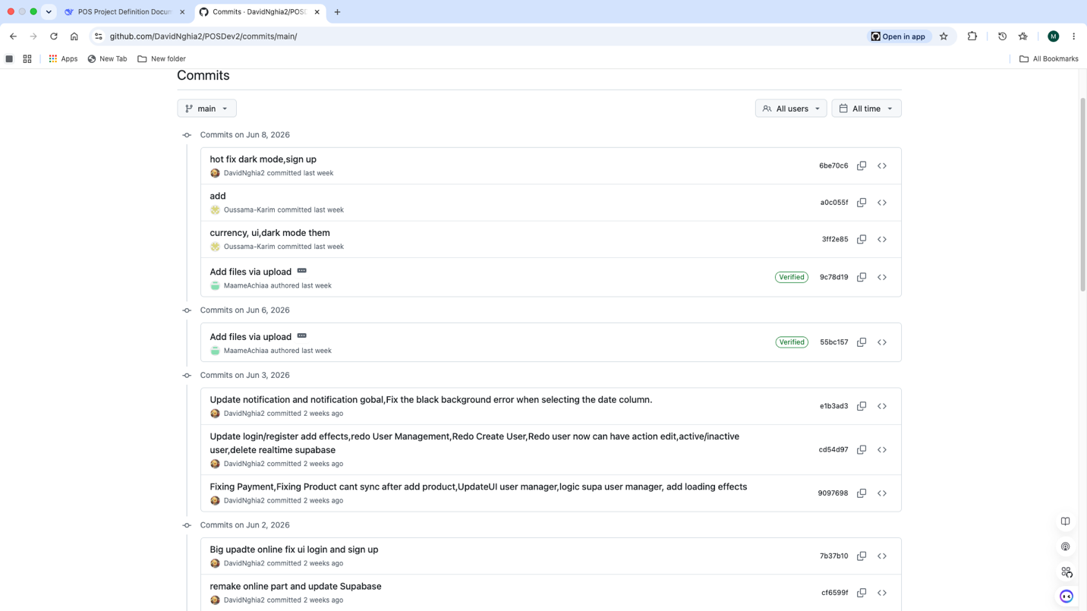

Figure 56

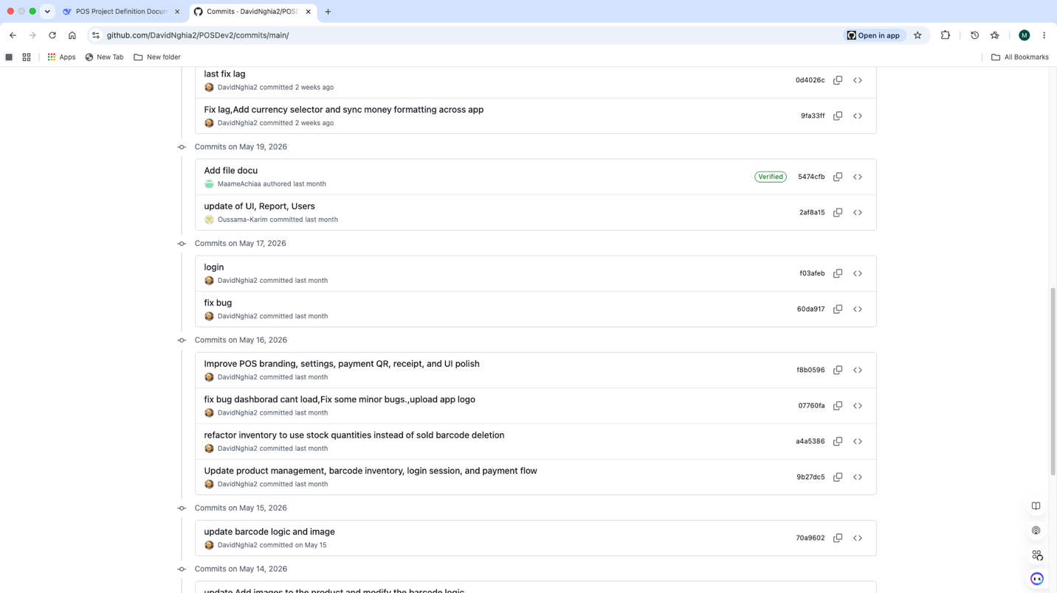

Figure 57

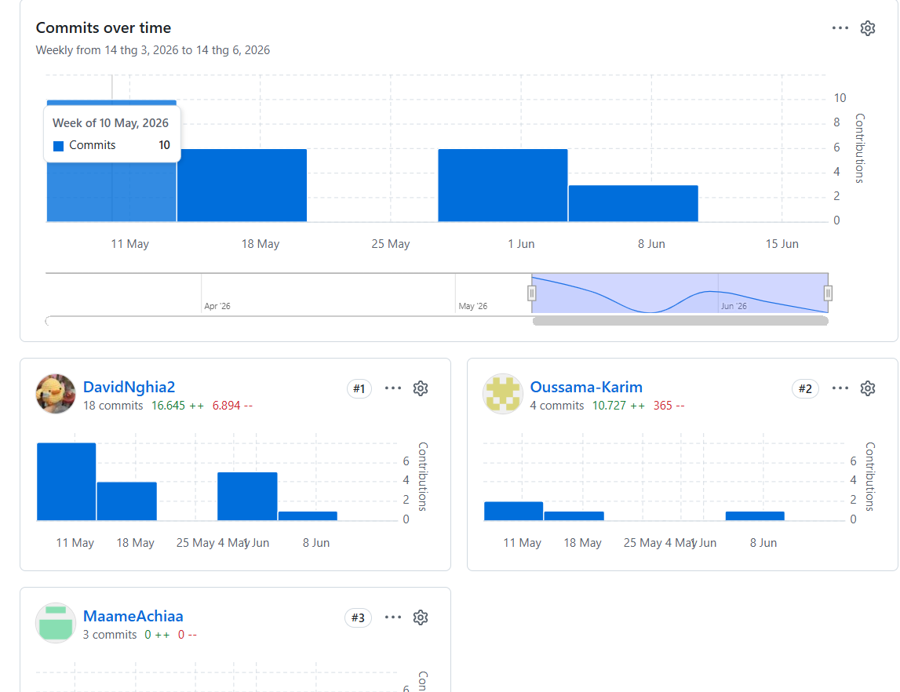

Figure 58

6.2. Peer Assesment
This document contains confidential peer evaluations completed by each team member. Each member has assessed the other two members' contributions, collaboration, technical skills, and overall performance. This assessment ensures accountability and fair recognition of individual efforts.
FROM | TO | FEEDBACK
Truong | Ossama | Contributions: Handled multiple roles effectively (FE/BE coding, supporting core testing, and test reporting).  Management: Strong leadership; effectively assigned tasks, tracked progress, and supported members with debugging.  Strengths: Responsible, hardworking, proactive in problem-solving, and kept the team on track.  Areas for Improvement: Should assign tasks earlier and document progress more clearly for easier team tracking.
Truong | Maame Achiaa | Contributions: In charge of synthesizing content, presenting features, describing the workflow, and preparing well-structured documentation.  Strengths: Careful, diligent in revising content, and possesses a strong sense of layout and organization.  Areas for Improvement: Should proactively communicate with the team earlier to gather technical details, ensuring the report aligns closely with the actual product.
Ossama | Troung | The interface is simple and easy to navigate, allowing users to perform daily tasks efficiently.  The checkout process is straightforward and supports multiple payment methods effectively.  Receipt generation provides clear transaction details and improves customer service.
Ossama | Maame Achiaa | Documentation well-structured with great system designed.
Maame Achiaa | Truong | 1. Excellent UI design skills  made the app look  professional  2. Clean code that was easy to test  3. Great Database
Maame Achiaa | Ossama | 1.Thorough testing caughtbugs before deployment  2. Beautiful UI andresponsive to feedback  3. Strong leadership and  technical expertise

Chapter Seven

7. System Deployment

7.2. Deployment Strategy Overview
The project is a Point of Sale (POS) desktop application built on Windows using a Thick Client combined with a Cloud Backend architecture. The deployment process is split into two independent yet tightly integrated subsystems:
- Cloud Backend (Supabase): Acts as the central data repository (Source of Truth), handling the database, authentication, storage, row-level security (RLS), and serverless functions.
- Desktop Client (Windows): The user interface built with Python and PyQt6. The application runs locally, utilizing SQLite as a runtime cache to optimize data retrieval speeds, and synchronizes data directly with Supabase via APIs.
The goal of this model is to ensure high performance for counter sales operations (locally) while leveraging the centralized management and security power of cloud computing.

7.3. Tools and Technologies Used
The deployment toolkit is categorized by technical function as follows:
Functional Group | Tool / Technology | Purpose
Client Environment | Python 3.12 | Main execution environment for the desktop application.
Client Interface | PyQt6, QtAwesome | UI construction framework and icon system.
Package Management | venv, pip | Creates independent virtual environments and manages dependencies in requirements.txt.
Client Automation | PowerShell | Executes setup scripts (setup.ps1) on Windows.
Packaging Tool | PyInstaller /Inno Setup | Packages the Python application into a standalone Windows executable (.exe). And Setup with Inno
Cloud Backend (BaaS) | Supabase | Platform providing Database, Auth, Storage, and Functions.
Database | PostgreSQL, SQLite | Cloud PostgreSQL stores primary data, local SQLite acts as a runtime cache.
Deployment CLI | Supabase CLI | Links projects, pushes migrations (schema), and deploys Edge Functions.
Source Control | Git / GitHub | Stores, versions, and synchronizes source code.

7.4. Detailed Deployment Workflow
The following section outlines the actual workflow from source code preparation to the POS system being ready for operation on the user's machine.

Step 1: Initialize and Configure Cloud Backend (Supabase)
A new Supabase project is created on the Dashboard. Critical connection details (Project URL and anon public key) are extracted for client use. Email confirmation is temporarily disabled under Authentication > Providers to optimize the account registration testing workflow.

Step 2: Link Source Code and Deploy Database Schema
On the administrator's workstation, the local project is linked to the Supabase cloud project via the CLI, and the data structure (Migration) is pushed to the cloud:
npx supabase link --project-ref YOUR_PROJECT_REF
npx supabase db push
This process automatically initializes the entire schema (tables such as stores, products, sales, etc.), indexes, Row Level Security (RLS) policies for multi-tenant data isolation and initializes the product-images bucket in Supabase Storage.

Step 3: Deploy Edge Functions (Server-side Logic)
For security reasons, the desktop application does not store the service role key. User account management tasks are delegated to Edge Functions. These functions are deployed to Supabase using the following commands:
npx supabase functions deploy admin-create-user
npx supabase functions deploy admin-update-user

Step 4: Set Up Desktop Client Environment
The user downloads the source code to a Windows machine. The .env.example file is copied to .env and updated with the SUPABASE_URL and SUPABASE_ANON_KEY. Subsequently, the automated environment setup script is executed:
.\setup.ps1
This script automatically creates a Python virtual environment, upgrades pip, installs the necessary libraries, and compiles core modules.

Step 5: Application Packaging
To deliver the software to end-users without requiring Python installation, the desktop client is compiled into a standalone standalone executable binary using PyInstaller or Nuitka:
pyinstaller --onedir --windowed main.py

Step 6: Launch and Operate the System
The compiled application executable is launched on the production client machine:
.\dist\main\main.exe
The system automatically configures a local SQLite cache at %LOCALAPPDATA%\RetailPOS\pos.db, loads the login interface, and stands ready for the initial Store Owner (Admin) account registration.

7.5. Post-Deployment Verification
To ensure the system operates stably, the following items are verified immediately upon completing the installation:
- Confirm the application successfully connects to Supabase via the API Key.
- Verify the first Store Owner is correctly initialized with the admin role.
- Product data (information and images) successfully syncs bidirectionally between the Local Cache and Supabase PostgreSQL/Storage.
- Core sales transactions (Sales, Payments) are recorded accurately with high responsiveness.
- Edge Functions successfully execute privilege delegation and user creation without exposing security credentials.

7.6. Operations and Security Standards (Best Practices)
- Environment Variable Management: The .env file containing project identification data is added to. gitignore to prevent leaks onto GitHub.
- Multi-Tenant Security: The system strictly applies PostgreSQL Row Level Security (RLS), ensuring each store can only query and manipulate its own data partition.
- Runtime Optimization: The local pos.db database serves only as a temporary buffer (cache) and is not packaged with the source code. This mechanism reduces load on the Cloud Database and allows the application to respond to UI actions in real-time.
- Privilege Delegation Principle: Clear separation of privileges is maintained by offloading sensitive tasks (Creating/Editing users) to Edge Functions instead of handling them directly within the Desktop Client. The high-privileged service role key is strictly forbidden from being embedded inside the client binary.

GitHub Link
https://github.com/DavidNghia2/POSDev2.git

